**MCU**

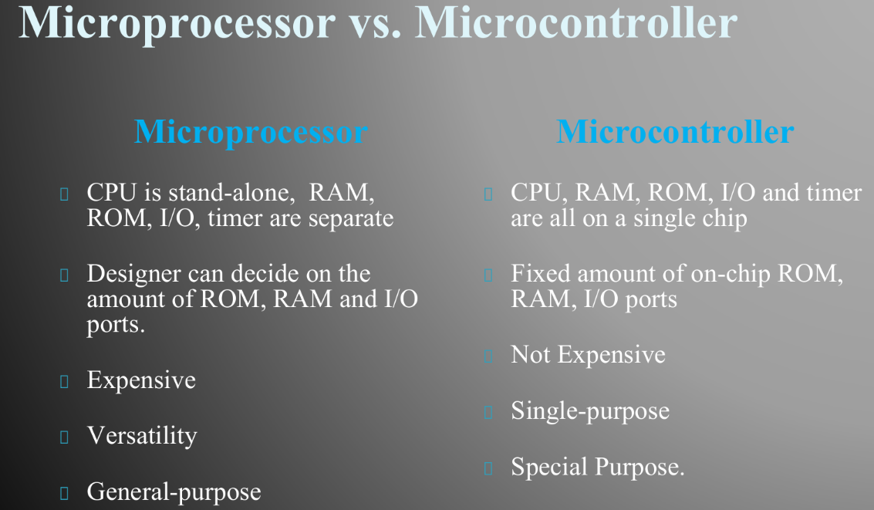



**Types of architecture:**

* Harvard
* Von Neumann Architecture

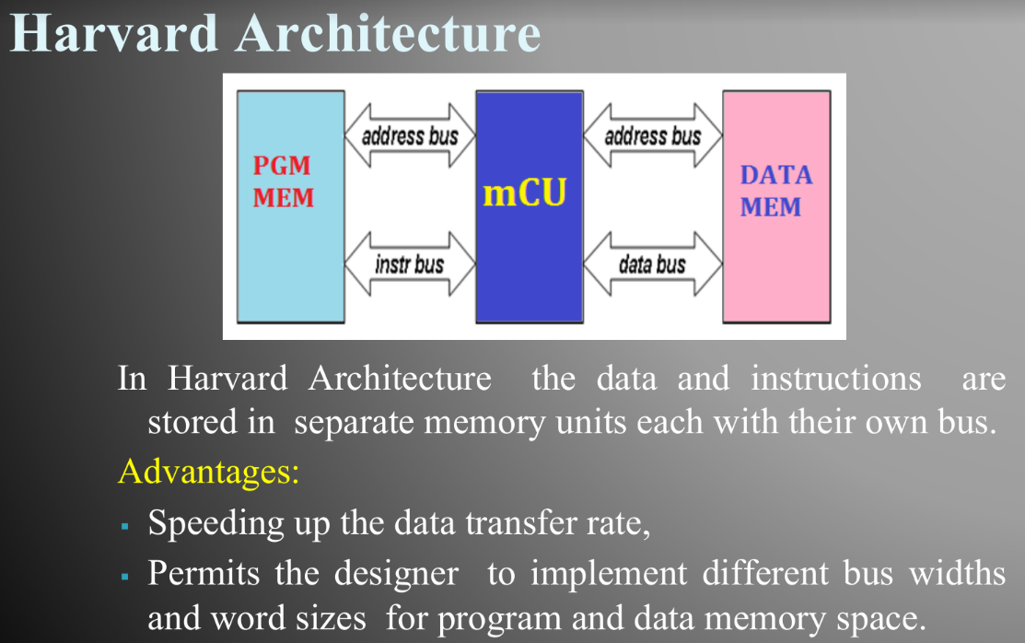

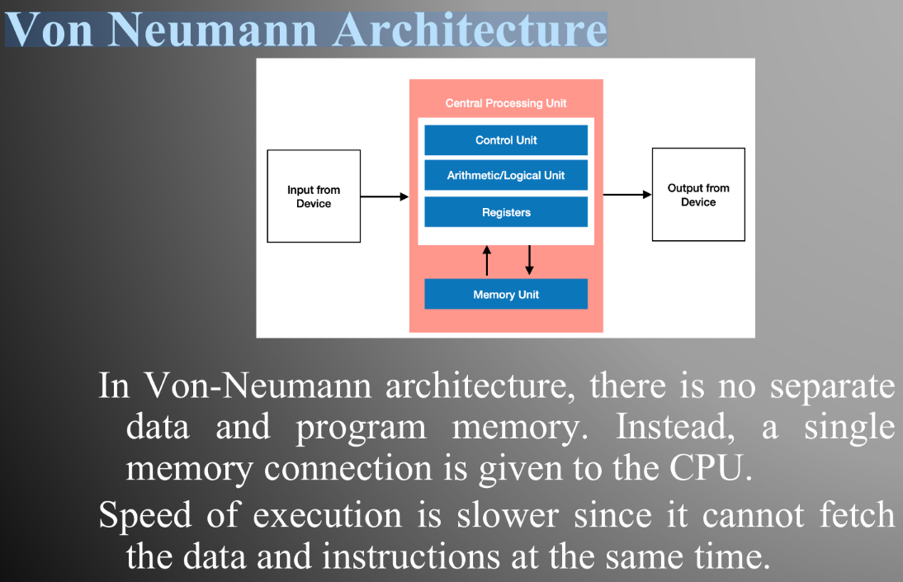

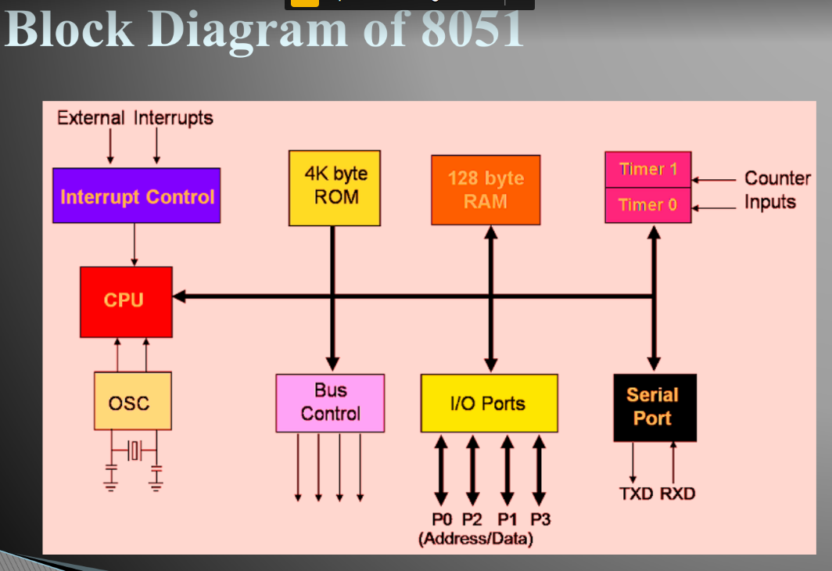

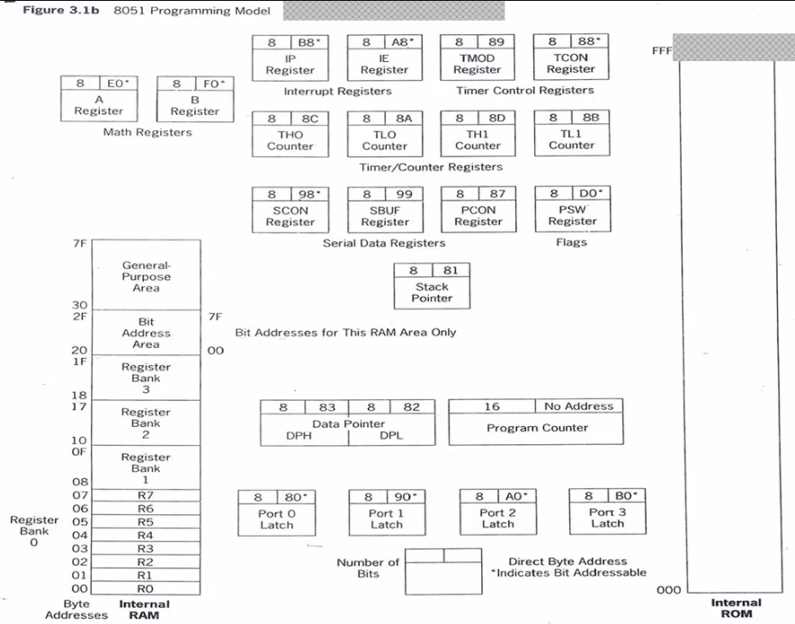

**Single Bit Instructions**

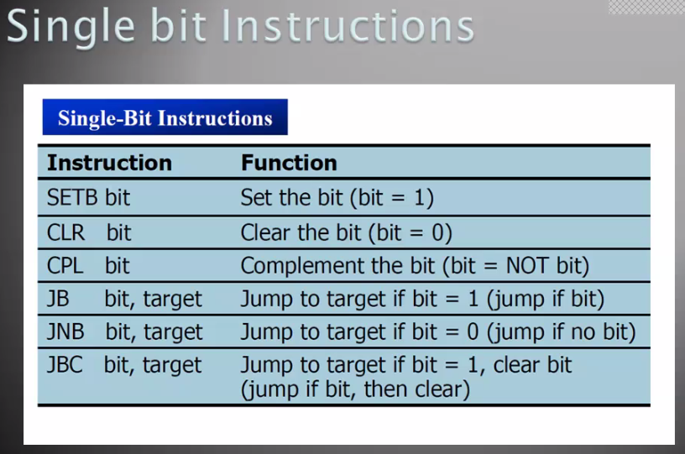

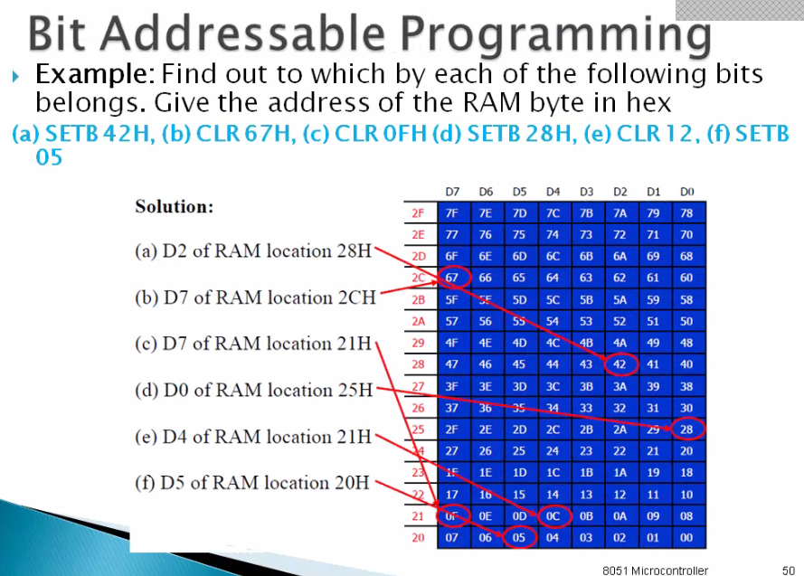

**Gyroscope**

#include "mbed.h"

// Sensors drivers present in the BSP library

#include "stm32l475e_iot01_tsensor.h"

#include "stm32l475e_iot01_hsensor.h"

#include "stm32l475e_iot01_psensor.h"

#include "stm32l475e_iot01_magneto.h"

#include "stm32l475e_iot01_gyro.h"

#include "stm32l475e_iot01_accelero.h"

DigitalOut led(LED1);

int main()

{

float sensor_value = 0;

int16_t pDataXYZ[3] = {0};

float pGyroDataXYZ[3] = {0};

printf("Start sensor init\n");

BSP_TSENSOR_Init();

BSP_HSENSOR_Init();

BSP_PSENSOR_Init();

BSP_MAGNETO_Init();

BSP_GYRO_Init();

BSP_ACCELERO_Init();

while(1) {

printf("\nNew loop, LED1 should blink during sensor read\n");

led = 1;

sensor_value = BSP_TSENSOR_ReadTemp();

printf("\nTEMPERATURE = %.2f degC\n", sensor_value);

sensor_value = BSP_HSENSOR_ReadHumidity();

printf("HUMIDITY = %.2f %%\n", sensor_value);

sensor_value = BSP_PSENSOR_ReadPressure();

printf("PRESSURE is = %.2f mBar\n", sensor_value);

led = 0;

ThisThread::sleep_for(1000);

led = 1;

BSP_MAGNETO_GetXYZ(pDataXYZ);

printf("\nMAGNETO_X = %d\n", pDataXYZ[0]);

printf("MAGNETO_Y = %d\n", pDataXYZ[1]);

printf("MAGNETO_Z = %d\n", pDataXYZ[2]);

BSP_GYRO_GetXYZ(pGyroDataXYZ);

printf("\nGYRO_X = %.2f\n", pGyroDataXYZ[0]);

printf("GYRO_Y = %.2f\n", pGyroDataXYZ[1]);

printf("GYRO_Z = %.2f\n", pGyroDataXYZ[2]);

BSP_ACCELERO_AccGetXYZ(pDataXYZ);

printf("\nACCELERO_X = %d\n", pDataXYZ[0]);

printf("ACCELERO_Y = %d\n", pDataXYZ[1]);

printf("ACCELERO_Z = %d\n", pDataXYZ[2]);

led = 0;

ThisThread::sleep_for(1000);

}

}

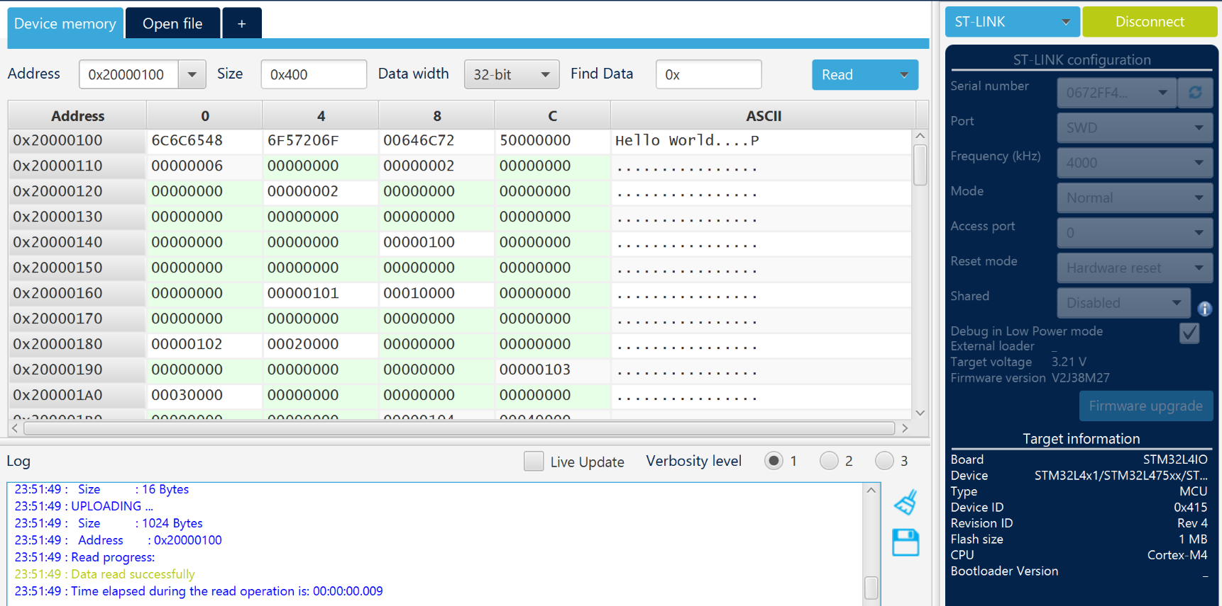

**Communication protocol:**

* **I2c**

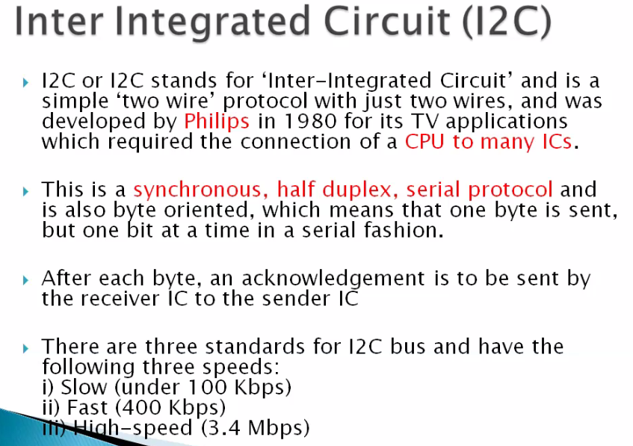

* **SPI**

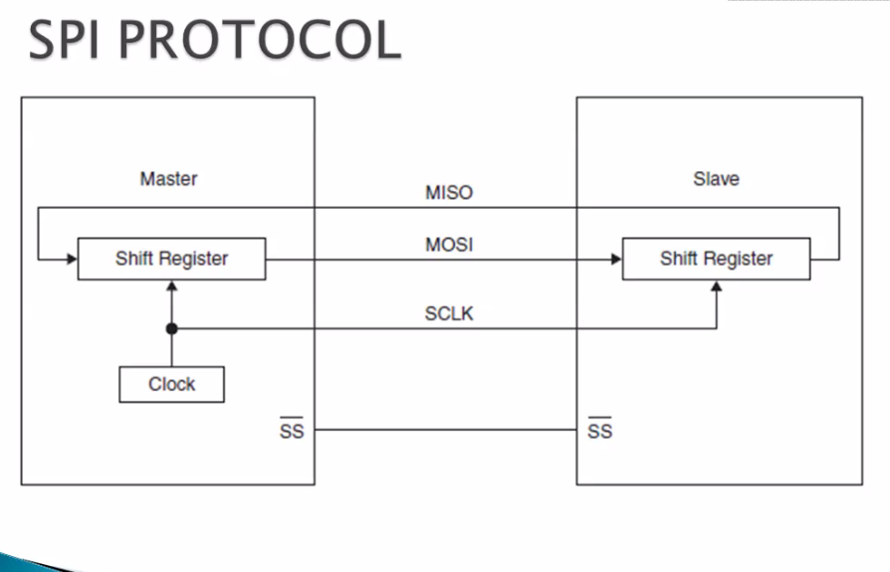

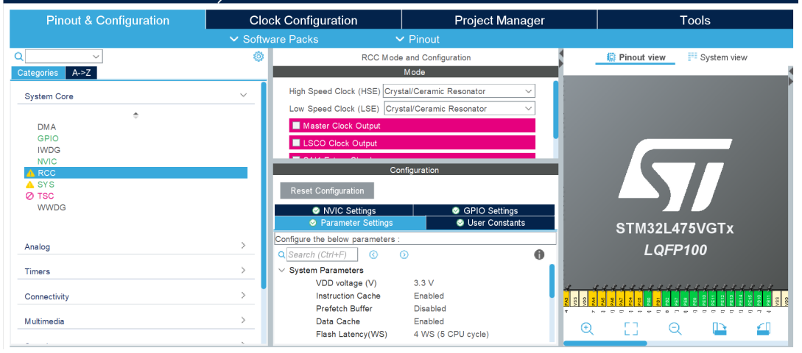

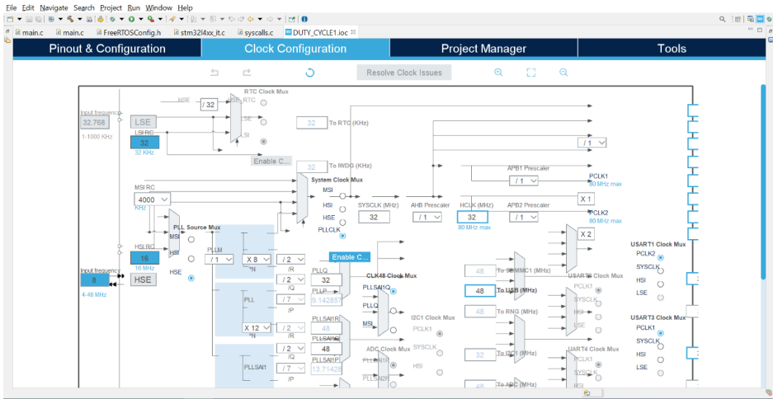

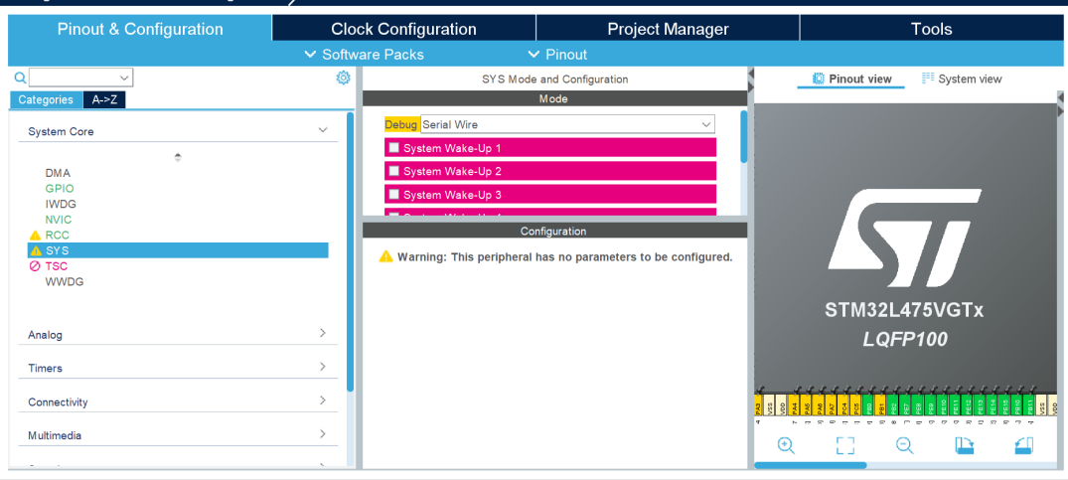

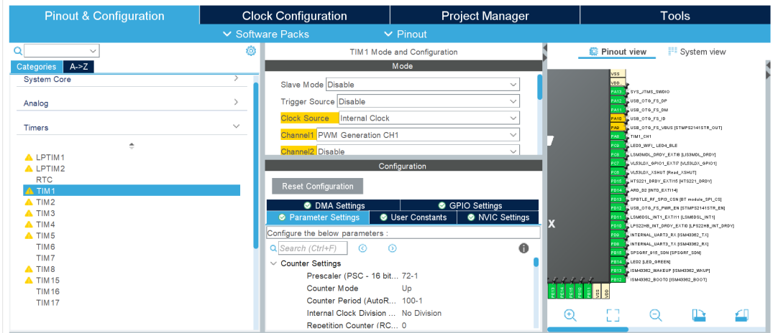

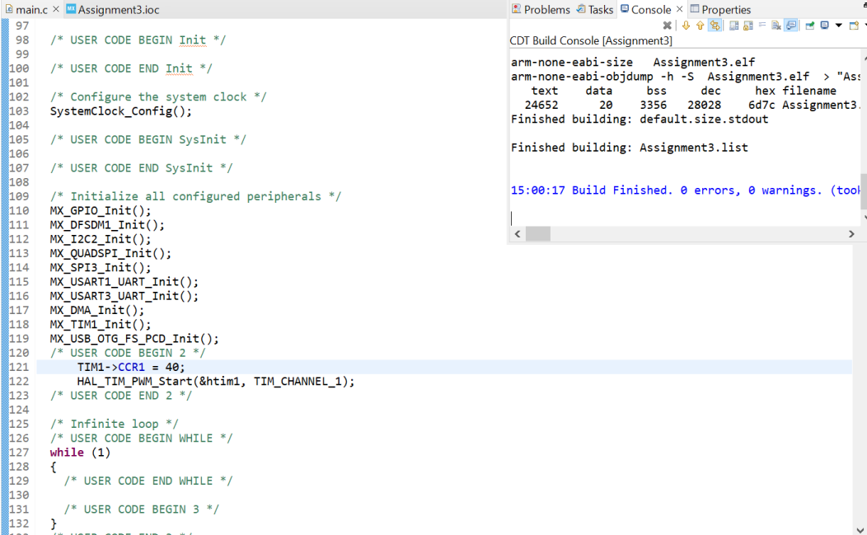

* **FreeRTOS**

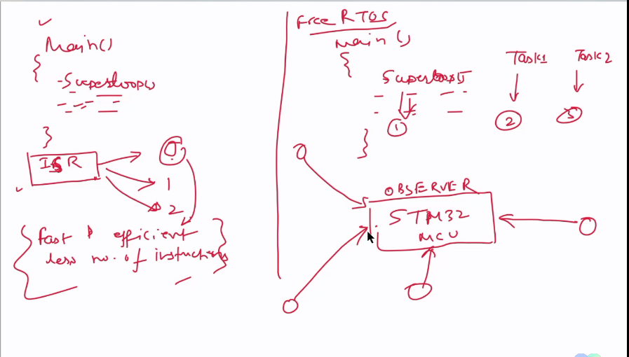

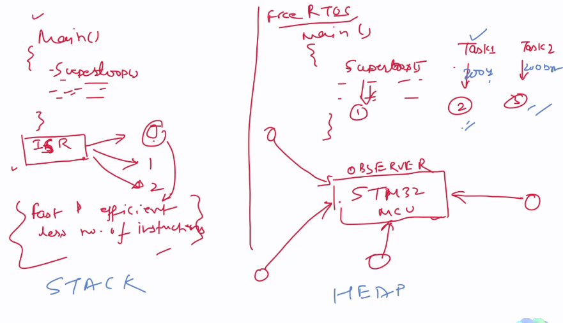

**Using FreeArtos**

/* USER CODE END Header_Task1_App */

**void** **Task1_App**(**void** **const** * argument)

{

/* USER CODE BEGIN Task1_App */

/* Infinite loop */

**for**(;;)

{

**printf**("Task1\n");

HAL_GPIO_WritePin(LED14_GPIO_Port, GPIO_PIN_14, 1);

**printf**("LED 14 ON\n");

HAL_Delay(500);

HAL_GPIO_WritePin(LED14_GPIO_Port, GPIO_PIN_14, 0);

**printf**("LED 14 OFF\n");

HAL_Delay(500);

taskYIELD();

osDelay(1);

}

/* USER CODE END Task1_App */

}

**void** **Task2_App**(**void** **const** * argument)

{

/* USER CODE BEGIN Task2_App */

/* Infinite loop */

**for**(;;)

{

**printf**("Task2\n");

HAL_GPIO_WritePin(LED5_GPIO_Port, GPIO_PIN_5, 1);

**printf**("LED 5 ON\n");

HAL_Delay(500);

HAL_GPIO_WritePin(LED5_GPIO_Port, GPIO_PIN_5, 0);

**printf**("LED 5 OFF\n");

HAL_Delay(500);

taskYIELD();

osDelay(1);

}

/* USER CODE END Task2_App */

}

**void** **Task3_App**(**void** **const** * argument)

{

/* USER CODE BEGIN Task3_App */

/* Infinite loop */

**for**(;;)

{

**printf**("Task3\n");

HAL_GPIO_WritePin(LED9_GPIO_Port, GPIO_PIN_9,1);

**printf**("LED 9 ON\n");

HAL_Delay(500);

HAL_GPIO_WritePin(LED9_GPIO_Port, GPIO_PIN_9,0);

**printf**("LED 9 OFF\n");

HAL_Delay(500);

taskYIELD();

osDelay(1);

}

/* USER CODE END Task3_App */

}

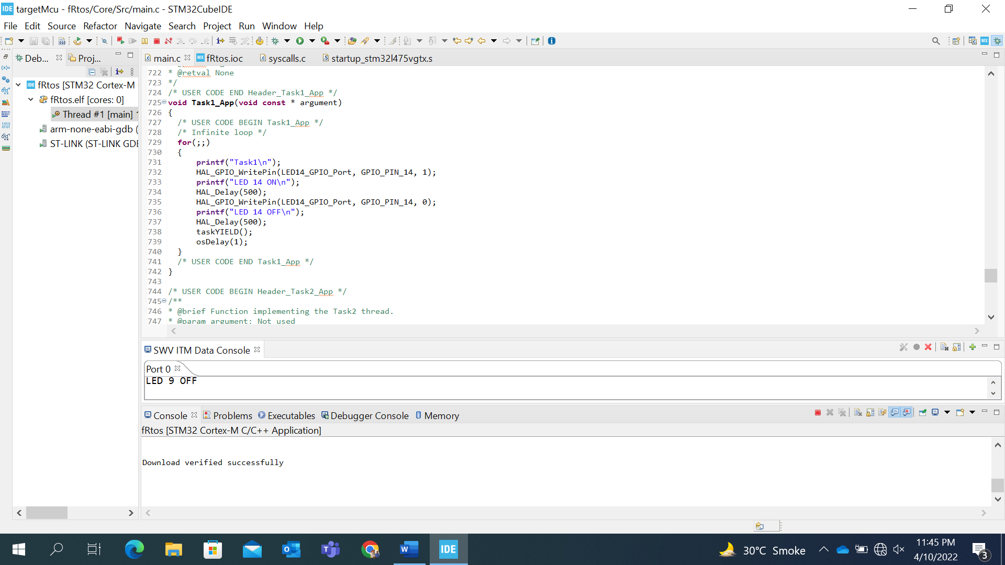

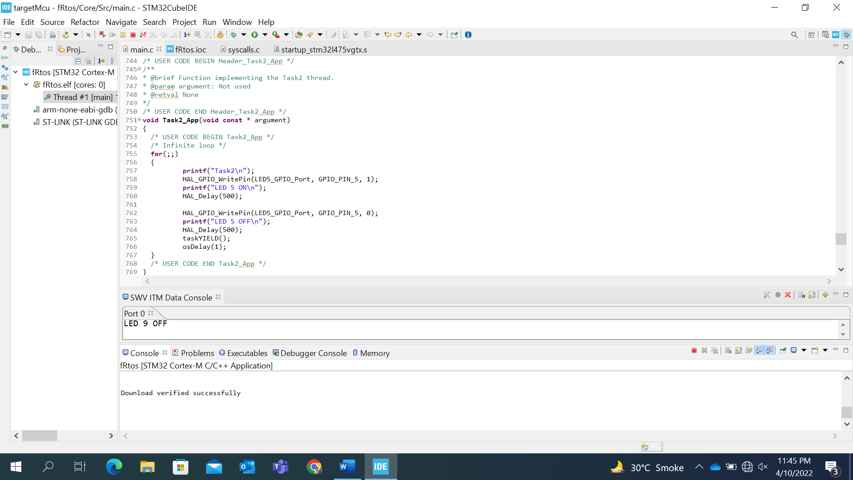

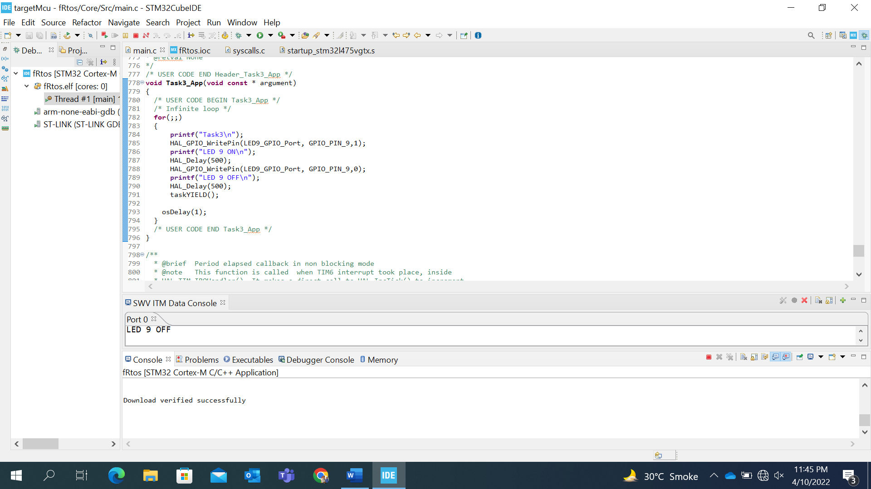

**Using Timmer**

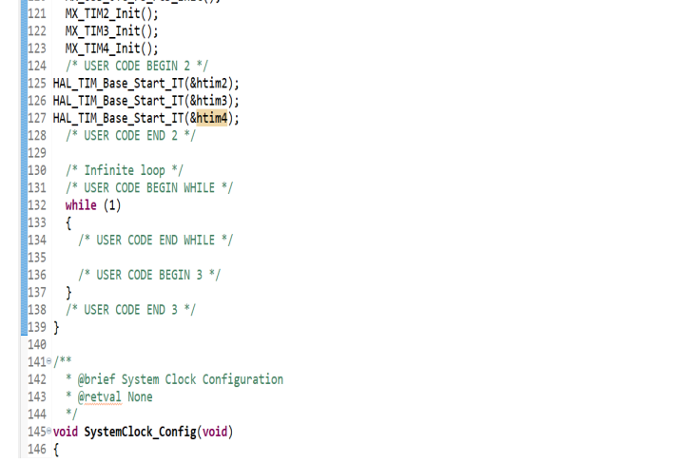

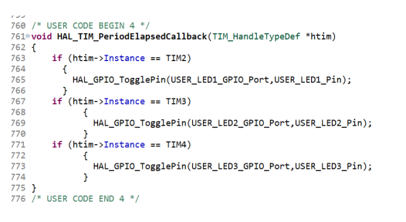

Stm32 works as an observer for different bluetooth beacons/advertisers. This works on a heap memory.

**Segger :**

From memory base export the file and save in .SVdat extension Need to create a .SVdat file and load in segger software to analyze the task1 & task2.

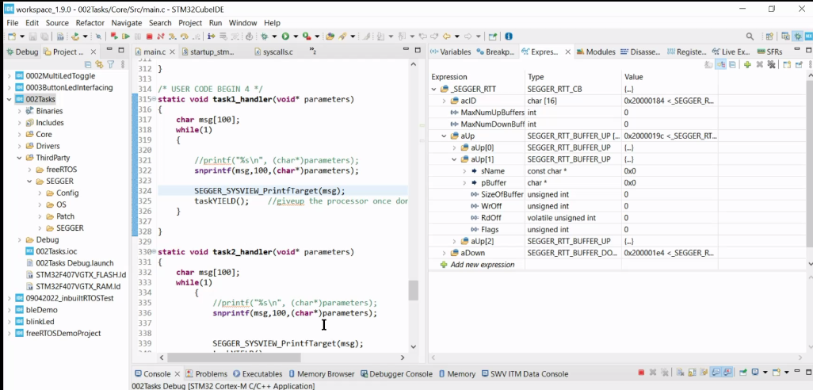

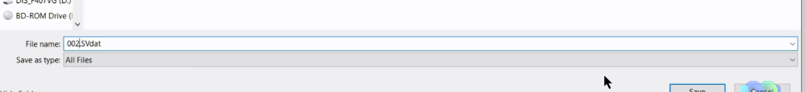

**timer**

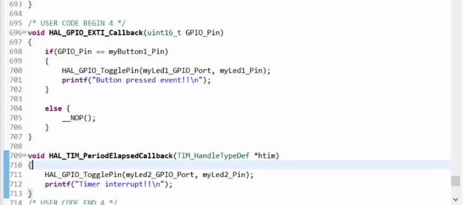

**LCD Interfacing link**

<https://github.com/prasanpro/STM32L475-Discovery-freeRTOS/tree/main/lcd_i2c_interface>

**Interfacing Sensors:**

I2c ⇒ spi ⇒ hts221 [temperature] & lps22hb [pressure]

<https://github.com/STMicroelectronics/STM32CubeL4/tree/master/Drivers/BSP>

**Bluetooth**

st.com ⇒ site

Search x-cube-ble1

HCI ⇒ host controller Interface

TL ⇒ transport layer

**RAM & FLASH**

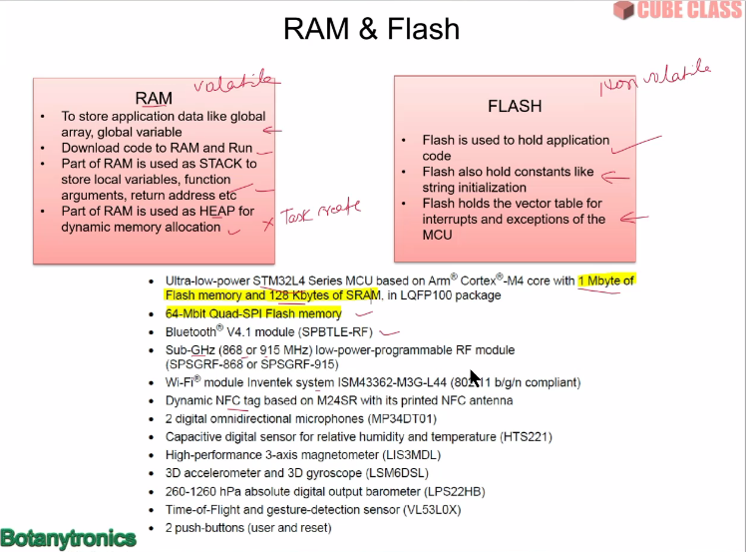

**Zephyr link**

<https://www.zephyrproject.org/>

**HEAP & STACK**

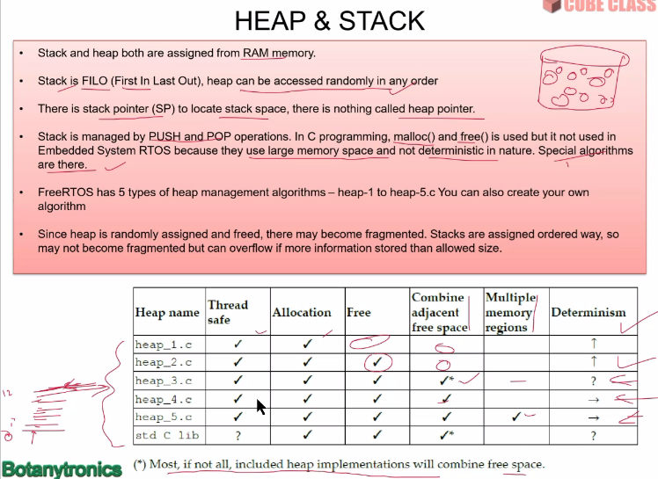

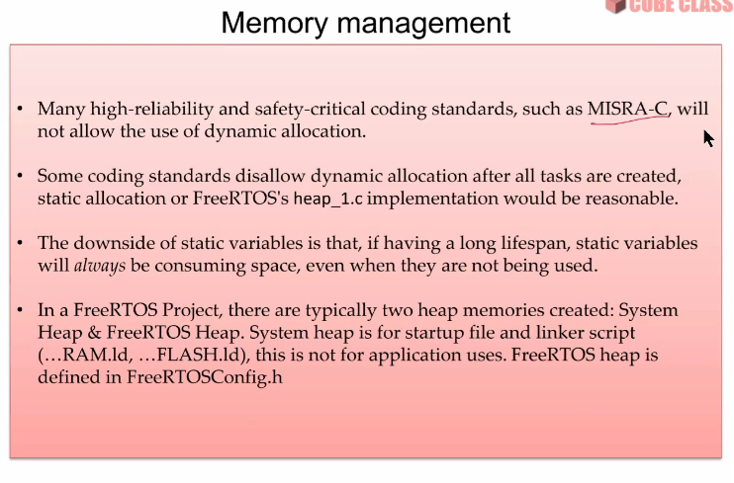

**UART**

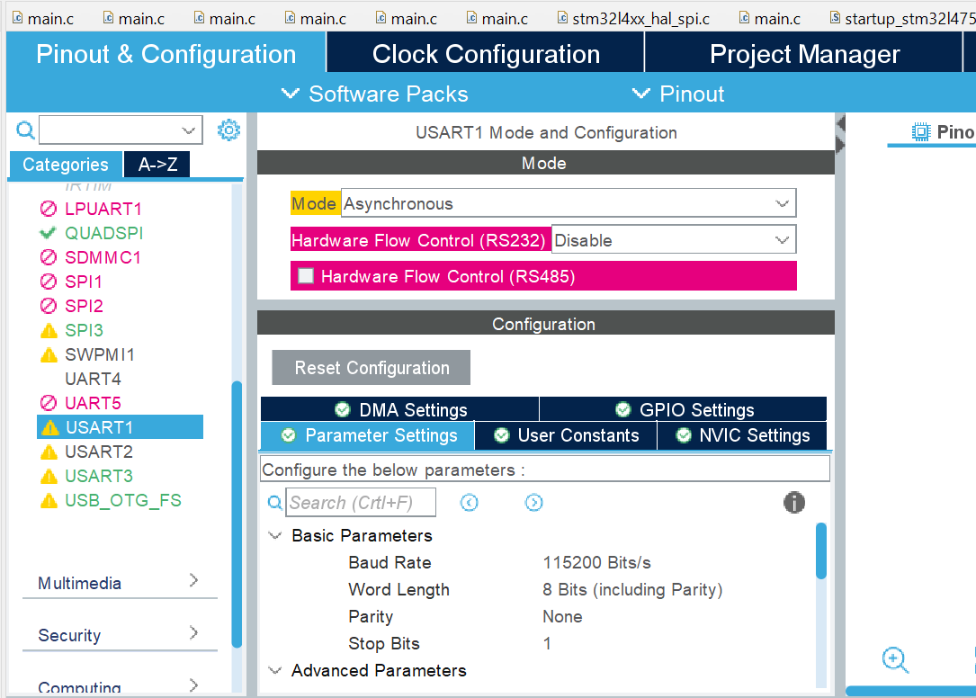

**Code:**

/* Private includes ----------------------------------------------------------*/

/* USER CODE BEGIN Includes */

**#include** <stdio.h>

/* USER CODE END Includes */

/* USER CODE BEGIN PV */

uint8_t uart_bfr, cmd;

uint8_t cmdstate=0;

uint8_t msg[] = "Hey, Welcome to UART demo!!";

uint8_t msg4[] = "Enter your choice: ";

uint8_t mesg[] = "Enter valid state";

uint8_t msg1[] = "LED1 ON\r\n";

uint8_t msg2[] = "LED1 & LED2 ON\r\n";

uint8_t msg3[] = "LED1 & LED2 OFF\r\n";

/* USER CODE END PV */

**int** **main**(**void**)

{

/* USER CODE BEGIN 1 */

/* USER CODE END 1 */

/* MCU Configuration--------------------------------------------------------*/

/* Reset of all peripherals, Initializes the Flash interface and the Systick. */

HAL_Init();

/* USER CODE BEGIN Init */

/* USER CODE END Init */

/* Configure the system clock */

SystemClock_Config();

/* USER CODE BEGIN SysInit */

/* USER CODE END SysInit */

/* Initialize all configured peripherals */

MX_GPIO_Init();

MX_DFSDM1_Init();

MX_QUADSPI_Init();

MX_SPI3_Init();

MX_USART1_UART_Init();

MX_USART3_UART_Init();

MX_USB_OTG_FS_PCD_Init();

MX_TIM1_Init();

/* USER CODE BEGIN 2 */

HAL_UART_Transmit(&huart1, msg, **sizeof**(msg), 100);

/* USER CODE END 2 */

/* Infinite loop */

/* USER CODE BEGIN WHILE */

**while** (1)

{

/* USER CODE END WHILE */

/* USER CODE BEGIN 3 */

HAL_UART_Transmit(&huart1, msg4, **sizeof**(msg4), 100);

HAL_UART_Receive(&huart1, &uart_bfr, **sizeof**(uart_bfr), 50000);

//HAL_UART_Receive_DMA(&huart1, &uart_bfr, 1);

HAL_UART_Transmit(&huart1, &uart_bfr, **sizeof**(uart_bfr), 100);

**printf**("3 Received state: %d\n", uart_bfr);

cmd = uart_bfr - '0';

**printf**("cmd: %d\n", cmd);

/*

if(cmdstate)

{

cmdstate = 0;

printf("In if cmd: %d\n",cmd);

*/

**switch**(cmd)

{

**case** 1:

HAL_GPIO_WritePin(myLed1_GPIO_Port, myLed1_Pin, 1);

HAL_GPIO_WritePin(myLed2_GPIO_Port, myLed2_Pin, 0);

HAL_UART_Transmit(&huart1, msg1, **sizeof**(msg1), 1000);

**printf**("case 1\n");

**break**;

**case** 2:

HAL_GPIO_WritePin(myLed1_GPIO_Port, myLed1_Pin, 1);

HAL_GPIO_WritePin(myLed2_GPIO_Port, myLed2_Pin, 1);

HAL_UART_Transmit(&huart1, msg2, **sizeof**(msg2), 1000);

**printf**("case 2\n");

**break**;

**case** 3:

HAL_GPIO_WritePin(myLed1_GPIO_Port, myLed1_Pin, 0);

HAL_GPIO_WritePin(myLed2_GPIO_Port, myLed2_Pin, 0);

HAL_UART_Transmit(&huart1, msg3, **sizeof**(msg3), 1000);

**printf**("case 3\n");

**break**;

**default**:

HAL_UART_Transmit(&huart1, mesg, **sizeof**(mesg), 1000);

**printf**("Enter valid state\n");

}

} // end while

} // end main

**Execution:**

Open the tera term 🡺 set serial to the COM of your ST-Link as we have choose USART1.

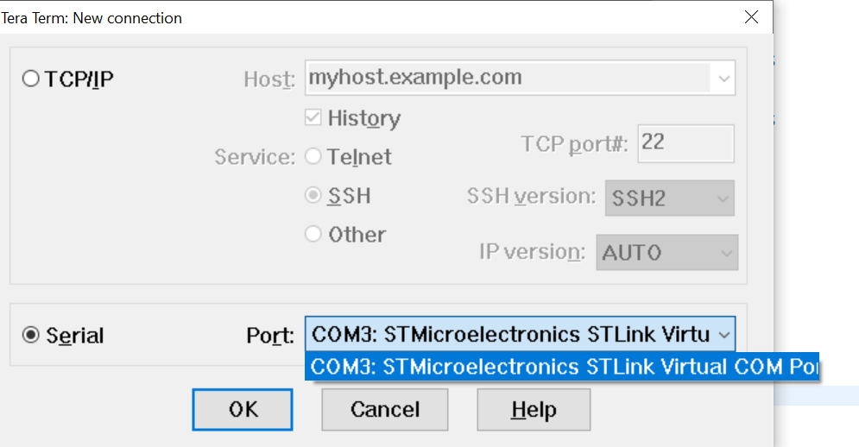

At first it will display garbage value, so we need to change the serial port setting and set the baudrate as 115200 bits/s.

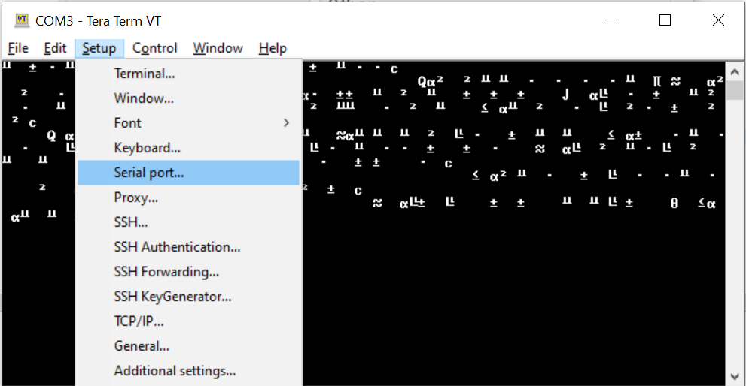

And save the new settings.

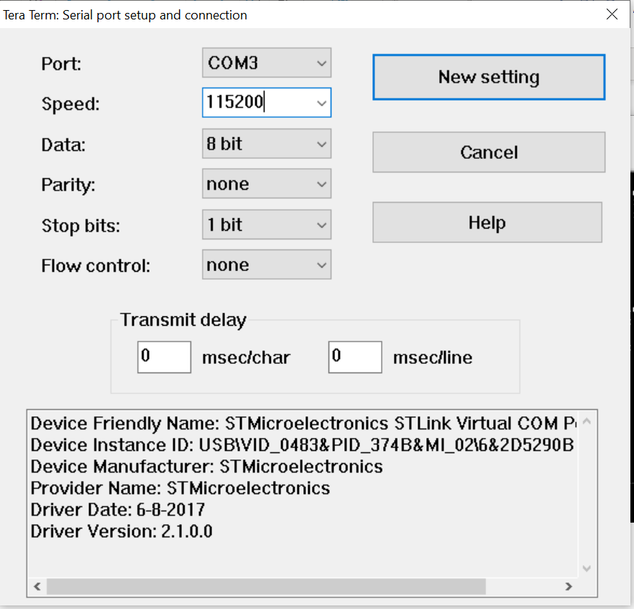

**Output:**

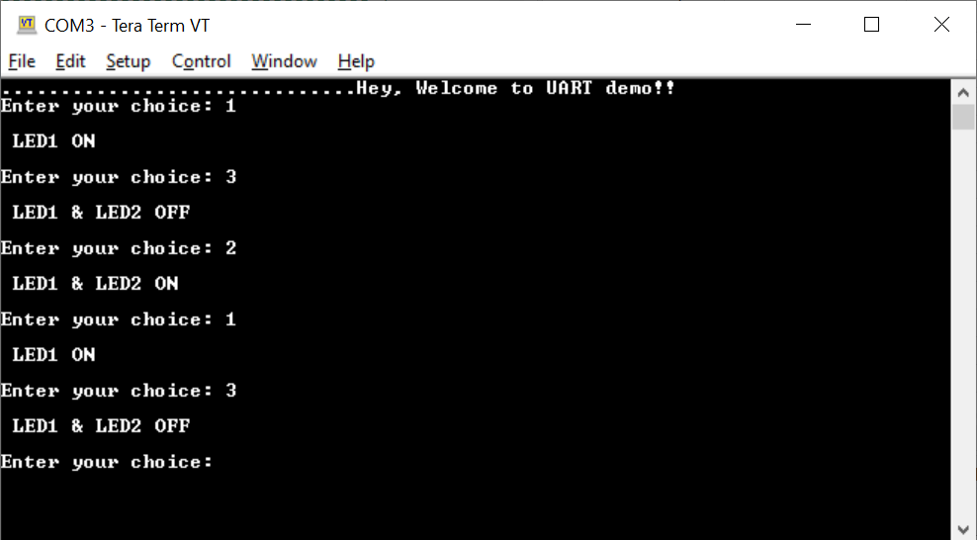

**BLE**

**Step-1:** **Start a new STM32Cube project**

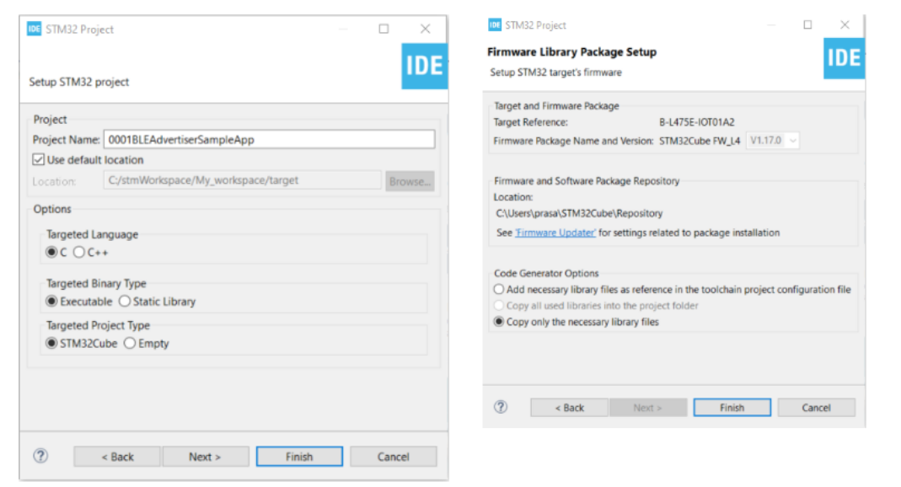

**Step-2: Open Device Configuration Wizard**

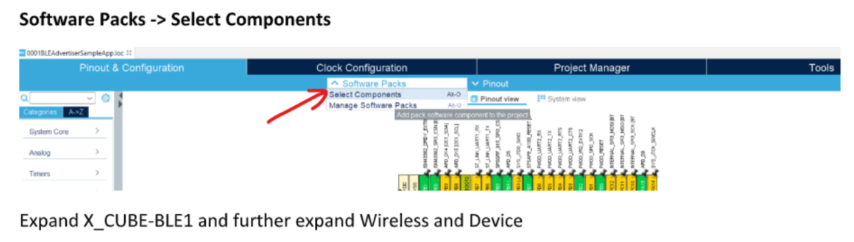

**Step-3: Select all configurations as shown above and click OK. It’ll add one additional Software Packs in configuration wizard.**

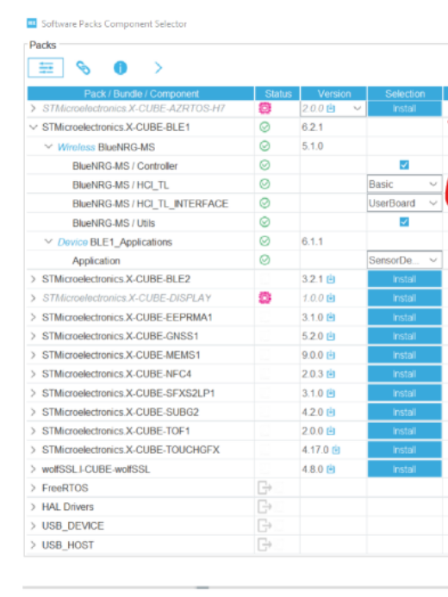

**Step-4 :Click on the newly added software pack and Enable both Wireless and Device BLE1 Application Mode.**

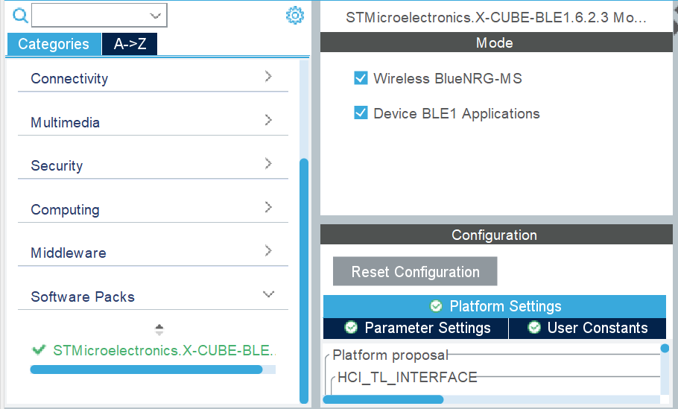

Enable SPI3 as out SPBTLE-RF module is interfaced with protocol

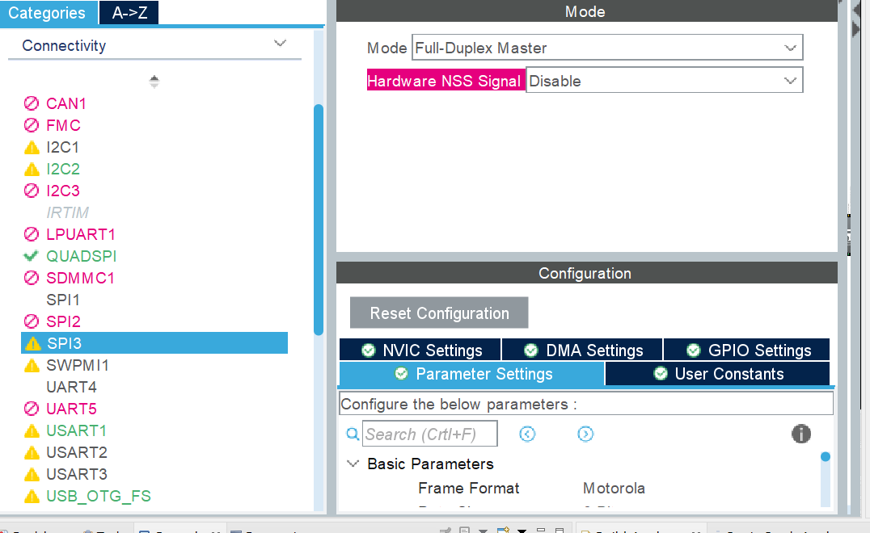

**Also enable USART1 for debugging**

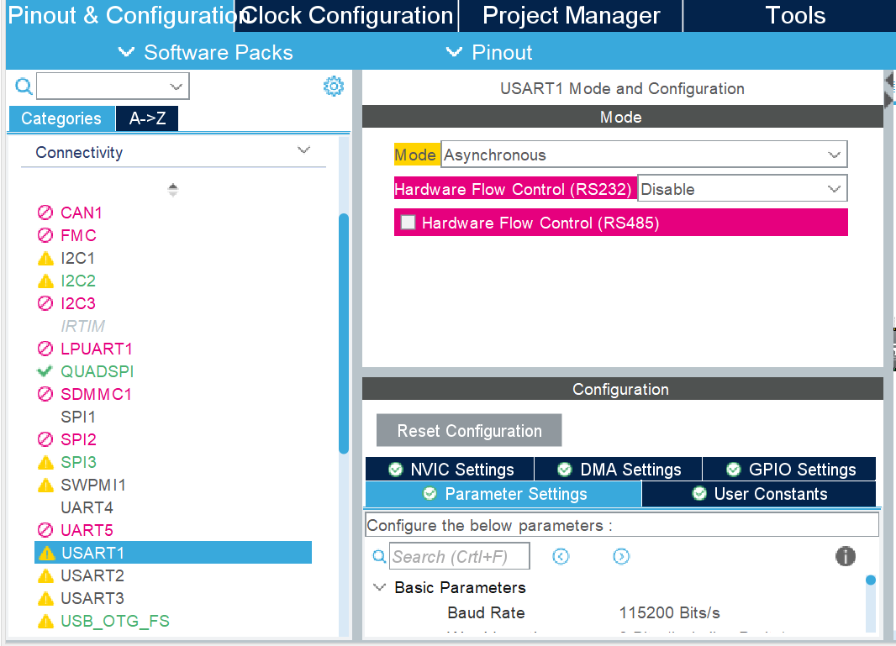

**Step-5: Check for the below condition in platform setting.**

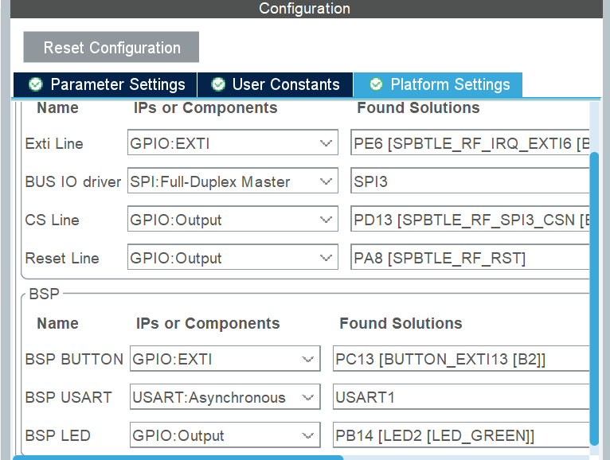

**Step-6: Install the ST BLE Sensor and couple your device. The temperature and pressure will appear, but they will be random numbers. To get the required parameters, follow the steps below:**

**Step-7: Include the Temperature and pressure file from BSP and include it to the app_bluenrg_ms.c**

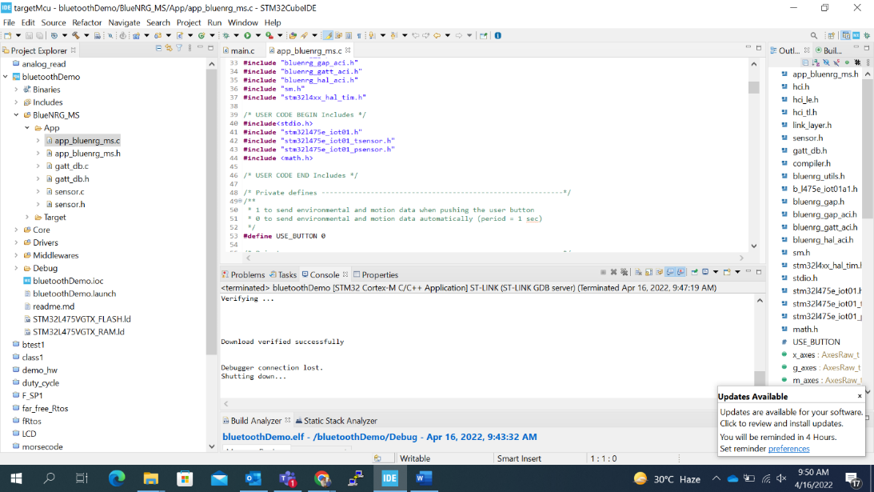

**Step-8: Add Print statement for printing the temperature and pressure values.**

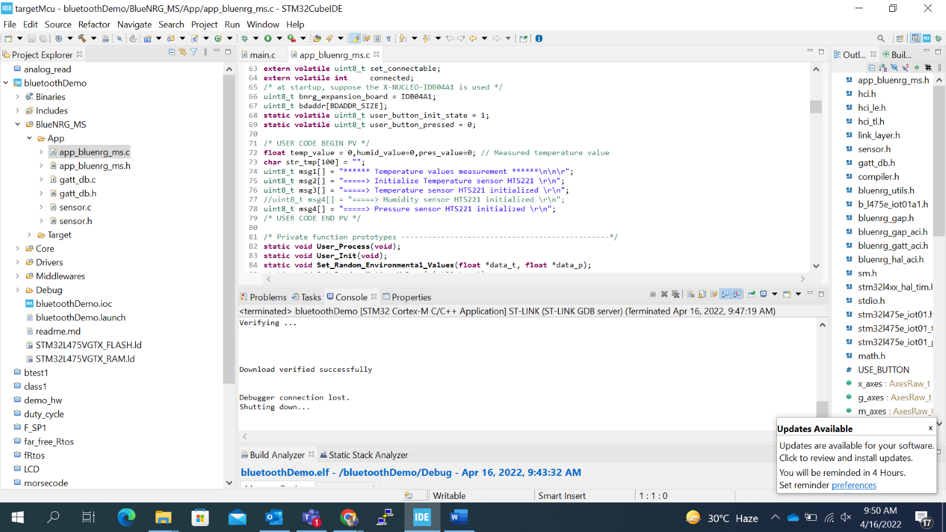

**Step-9: Initialized Temperature and pressure**

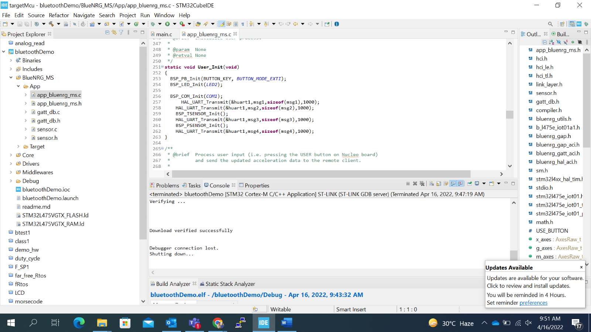

**Step-10: Include the formula for temperature and Pressure to get the accurate result.**

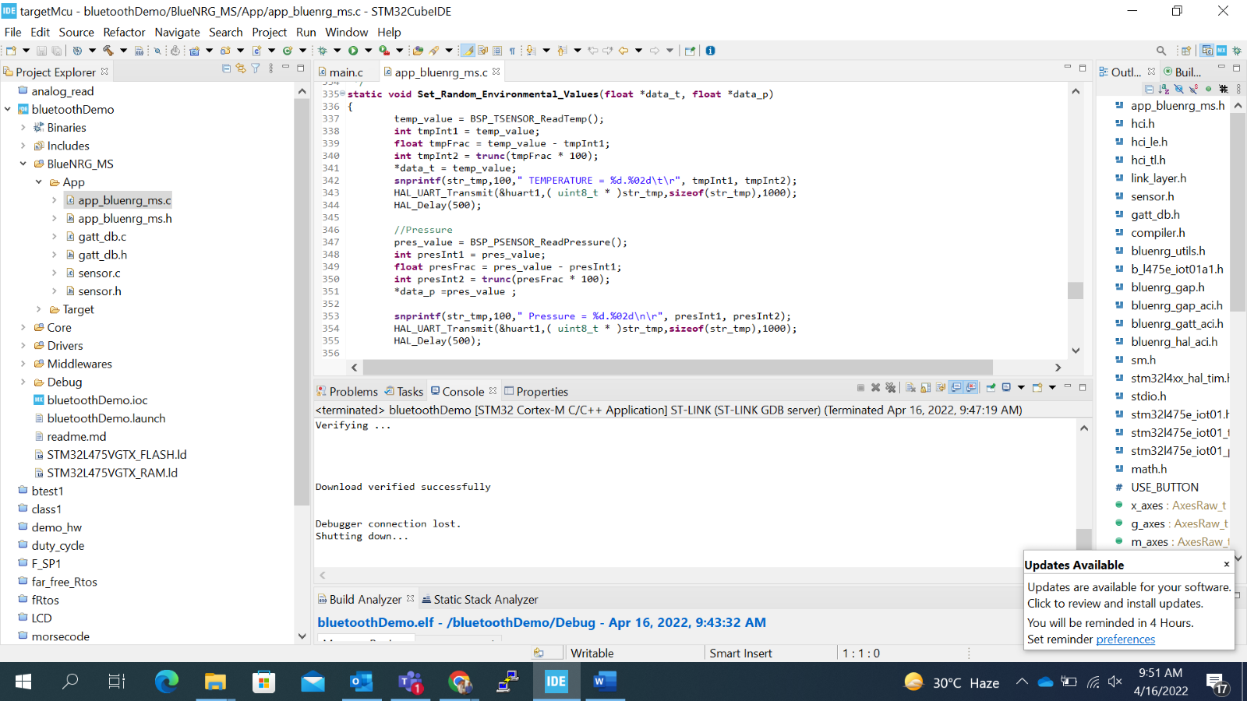

**Result:**

**Paired your device Mobile app(St Ble)**

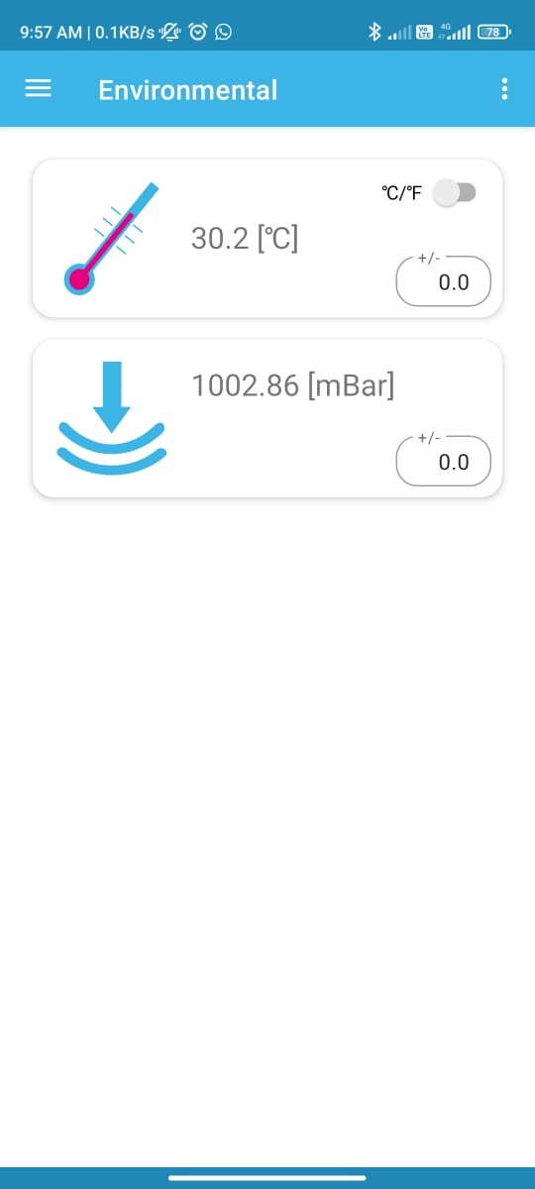

**Console (Putty) Output** :

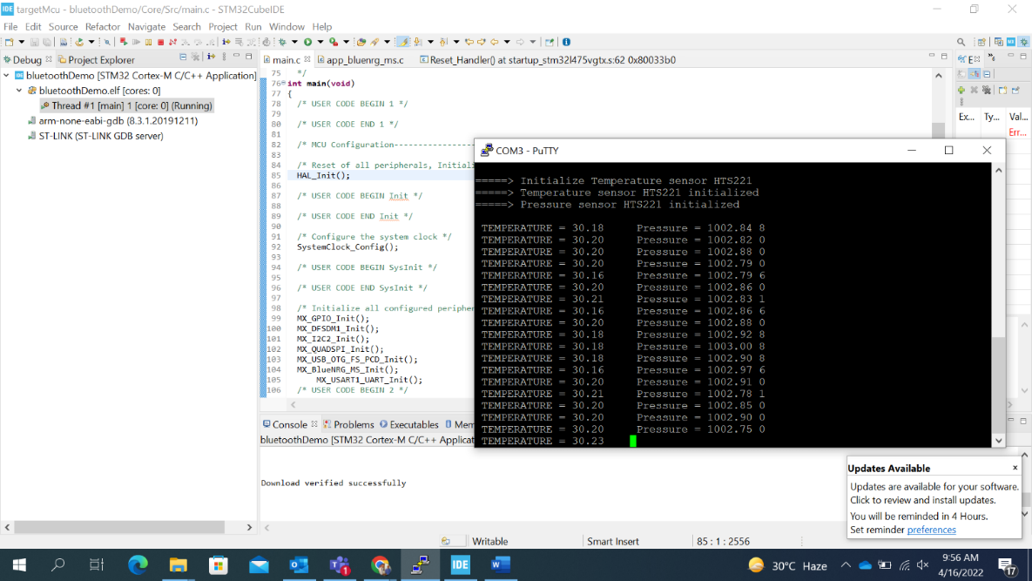

**Console (Tera term) Output** :

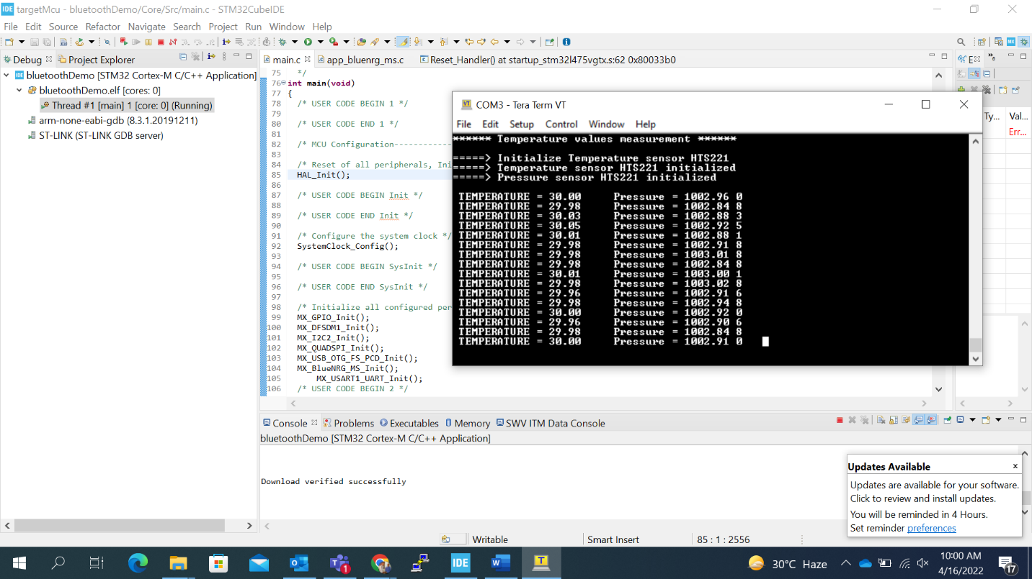

# **IOT**

Step-1

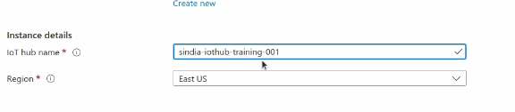

South east Asia



Step-2

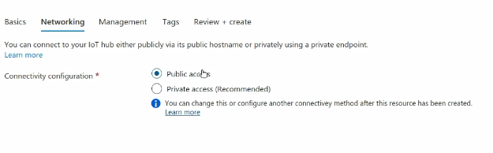



Step-3

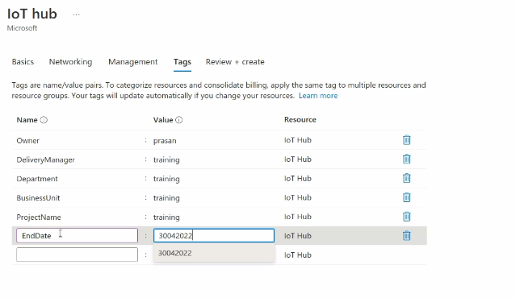

Step-4 To delete(go to the resource group and delete the deployment)

Step-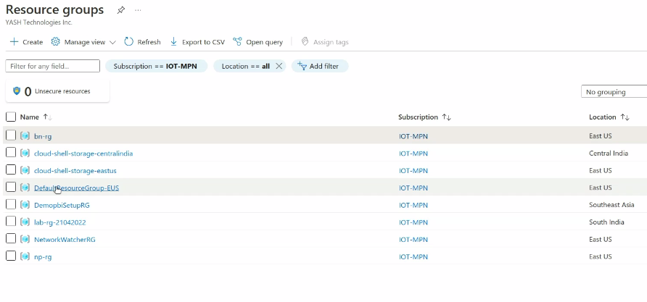

Step-5 go to device and add device

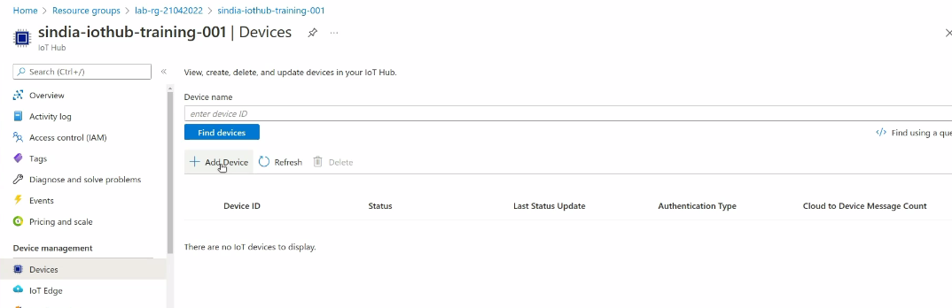

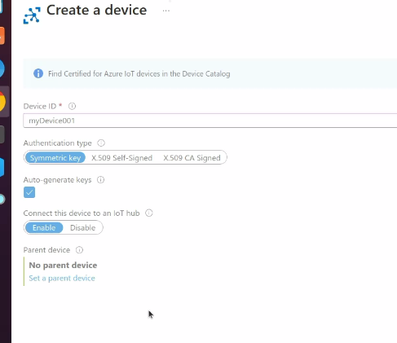

Step-6 Go to device twin

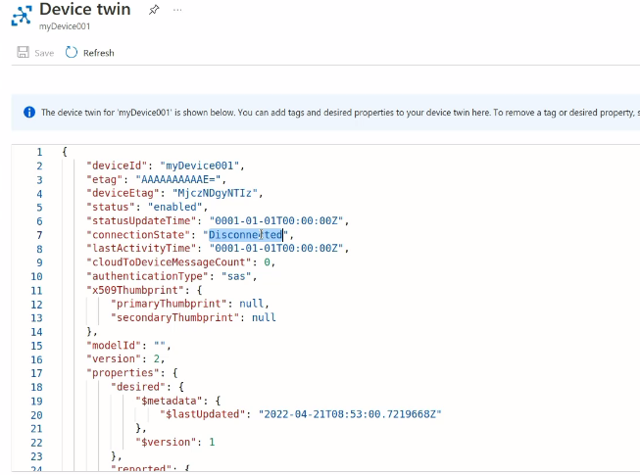

Visual stduio

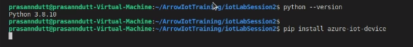

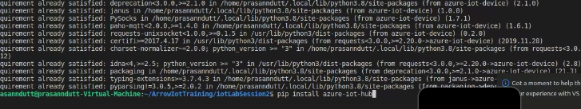

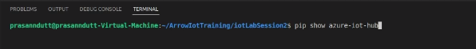

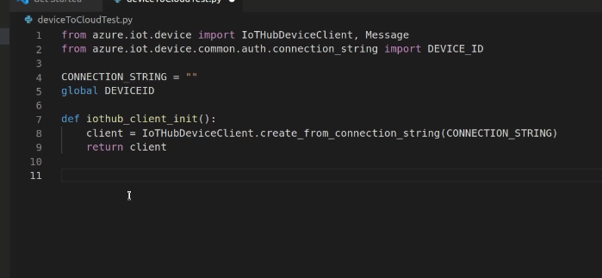

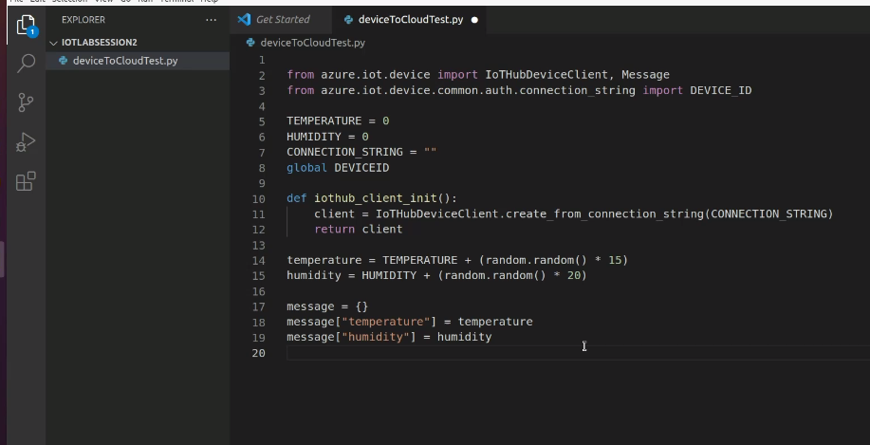

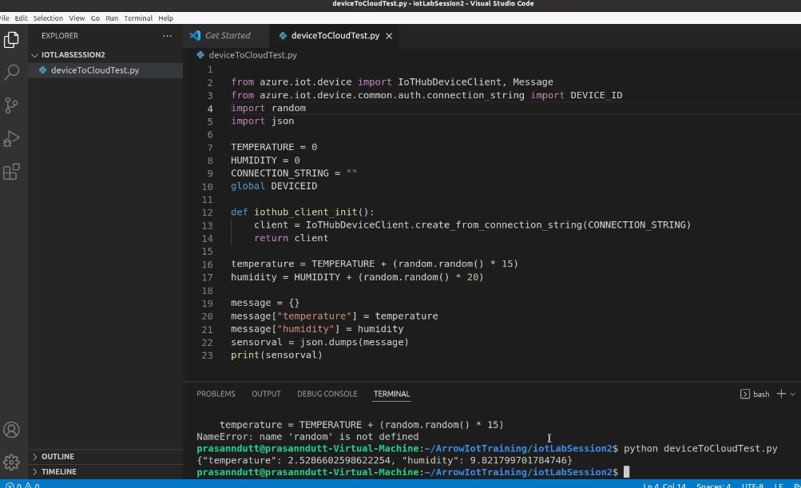

**MQTT**

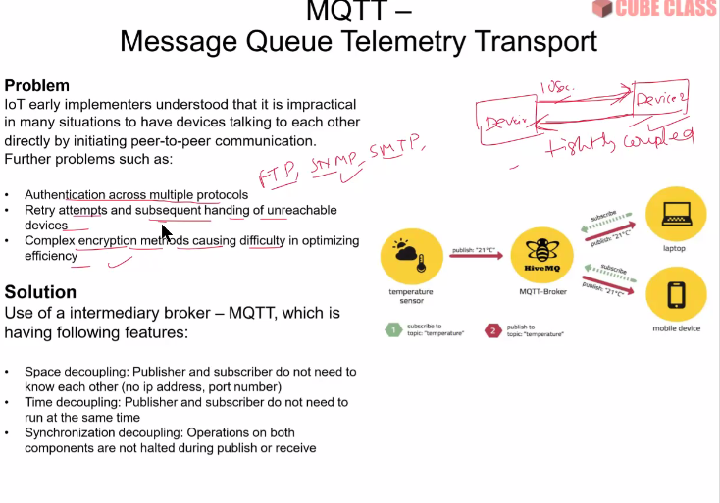

**MQTT** ⇒

Peer to peer(client) communication.

Tightly coupled devices.

As continues, acknowledgement and communication is needed. So, this type of communication can never achieve low energy.

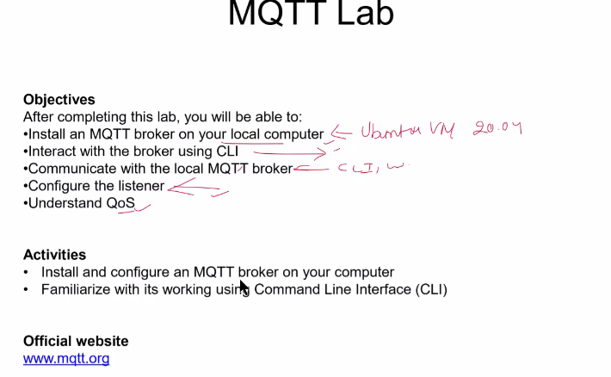

**Mqtt website**

<https://mqtt.org/>

**Mosquitto Linux**

Install

* sudo apt-add-repository ppa:mosquitto-dev/mosquitto-ppa
* sudo apt install mosquitto
* sudo apt install mosquitto-clients
* mosquitto --version

mosquitto_pub -t test -m "Hello World"

1. -t : topic name
2. -m : message
3. _pub : publisher

**Netstat grepping localhost**

netstat -a | grep 1883

* To know the local host, verifying mosquitto has published
* Post number: 1883, its by default port of mosquitto

Mosquitto publisher on one terminal and subscriber on another

Publisher:

mosquitto_pub -t test -m “hello testing”

Subscriber:

mosquitto_sub -t test

-t: topic, here topic is test and thus as subscribed to the same topic its showing the message published by mosquitto

* **#Include publisher.py code**
* **#Edit .json file**

{

"broker_host": "localhost",

"broker_port": 4665,

"devices": [

{

"type": "temperature",

"publish_frequency": 5,

"publish_topic": "devices/temp",

"std_val": 25,

"device_count": 1

},

{

"type": "humidity",

"publish_frequency": 7,

"publish_topic": "devices/hum",

"std_val": 40,

"device_count": 1

},

{

"type": "pressure",

"publish_frequency": 9,

"publish_topic": "devices/pre",

"std_val": 1004,

"device_count": 1

}

]

}

**Step:1 write command to open Node-red-start**

node-red-start

**Step:2 open the given url**

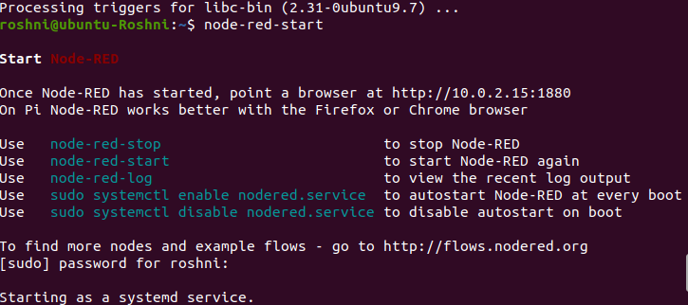



**Step:3 Implementation**

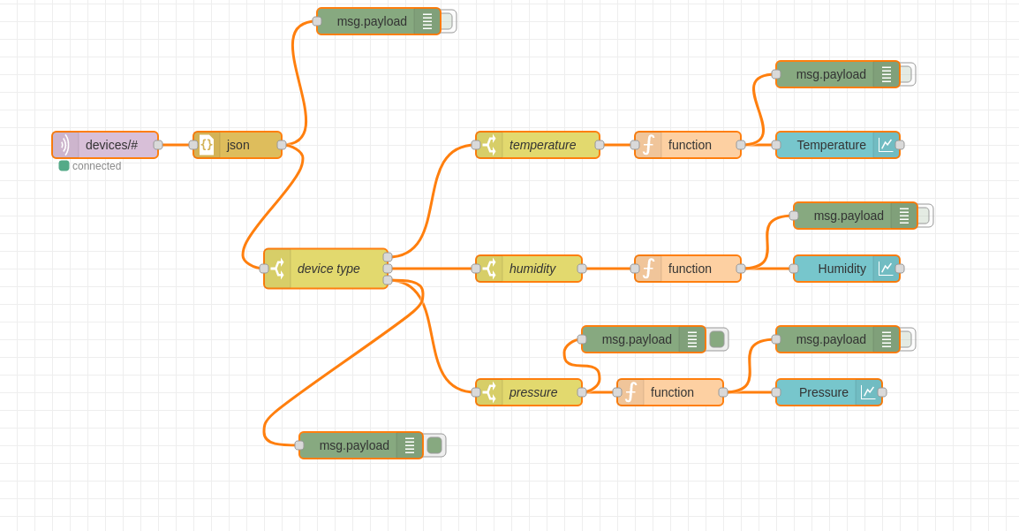

**Step:4 Change the following in function to get the data**

* Use to Convert Data into float data type

msg = msg.payload.value

return {payload:msg};

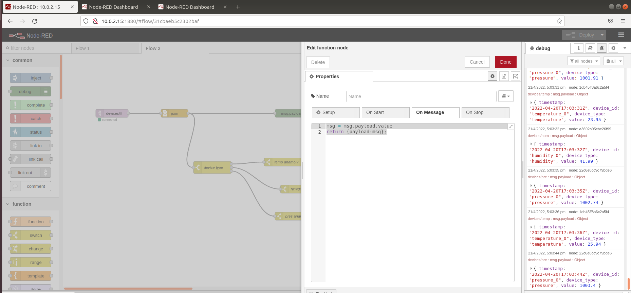

**Step:5 Results**

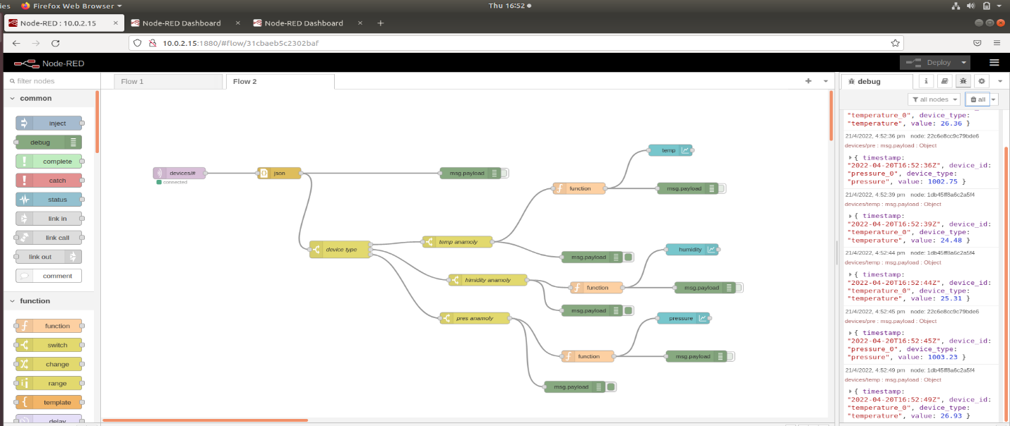

**Graph**

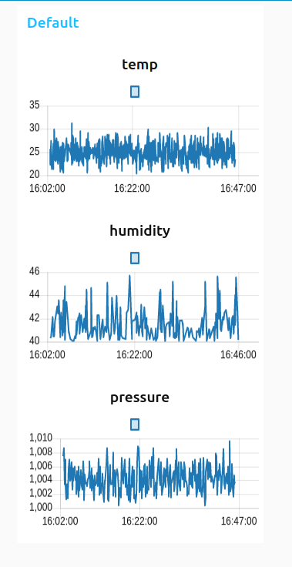

**Hierarchy for any topic concept**

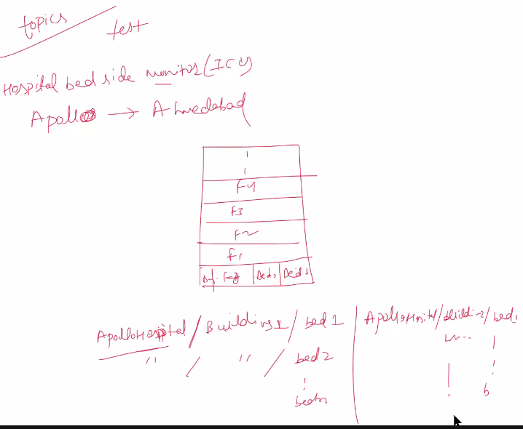

Topic : it’s a level or any sub-level or any other sub-level for sub-level.

**Wild cards**

1. Single level wildcards
   1. + sign representation
   2. generally for subscriber end not publisher end
   3. Ex: mosquitto_sub -t apollohospital/+/bed1
   4. This provides us data for any building in apollo hospital
2. Multi level wildcards
   1. # sign representation
   2. Topic end: generally for subscriber end not publisher end
   3. Ex: mosquitto_sub -t apolloHospital/building1/#
   4. This will give us data for any bed in apollo hospital

**Commands**

mosquitto_pub -t apolloHospital//bed1 -m "stream web" -d -i publisher

1. -d : used for debugging
2. -i : used for naming the client

mosquitto_sub -t apolloHospital/+/bed1 -d -i subscriber

1. Same as publisher
2. -d: debug
3. -i : naming the subscriber

**Note:**

At a time we can connect more than one subscriber to the publisher, which are using the same topic name and can be vice versa from different publishers we can same data to the any number of subscribers at the same time:

Example:

Publisher:

1. mosquitto_pub -t apolloHospital/build/bed1 -m "stream" -d -i publisher1
2. mosquitto_pub -t apolloHospital/build/bed1 -m "stream" -d -i publisher2

Subscriber:

1. mosquitto_sub -t apolloHospital/+/bed1 -d -i subscriber1
2. mosquitto_sub -t apolloHospital/+/bed1 -d -i subscriber2

**Json:**

Javascript object notation

It’s a combination of {“key” : “Value”} pairs.

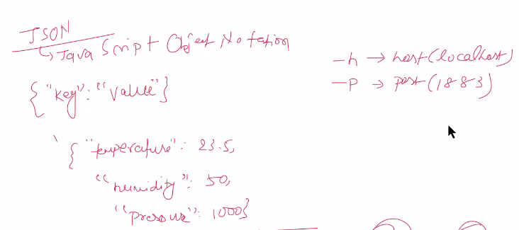



Online json viewer for verifying json data:

<http://jsonviewer.stack.hu/>

1. Create a .json file

gedit sampleData.json

{

"temperature": 27.5,

"Humidity": 58,

"Pressure": 1803

}

1. Start a subscriber on the same topic as publisher
   1. mosquitto_sub -t apolloHospital/+/bed1 -d -i subscriber2
2. On the publisher side
   1. mosquitto_pub -t apolloHospital/build/bed1 -f sampleData.json -d -i publisher
   2. Use -f <json file> instead of msg

publisher:

mosquitto_pub -t apolloHospital/build/bed1 -f sampleData.json -d -i publisher -h localhost -p 1883

1. -h : localhost
2. -p : port number

mosquitto_pub -t apolloHospital/build/bed1 -f sampleData.json -d -i publisher -h "127.0.0.1" -p 1883

1. Instead of localhost ⇒ 127.0.0.1 ⇒ this also works as ip addr of localhost is “127.0.0.1”

Subscriber:

mosquitto_sub -t apolloHospital/+/bed1 -d -i subscriber1 -h localhost -p 1883

host and port number should be the same and everything mentioned also needs to be the same.

The MQTT protocol allows messages with a maximum size of **268435455 bytes approx 260MB**.

**Qos: Quality of service**

1. 0: fire and forget
   1. Publisher send but broker doesn’t guarantee that subscriber will receiver the data
2. 1: at least once
   1. Duplicates may happen
3. 2: exactly once
   1. Duplicate will not happen

There is acknowledgement in all 3 cases.

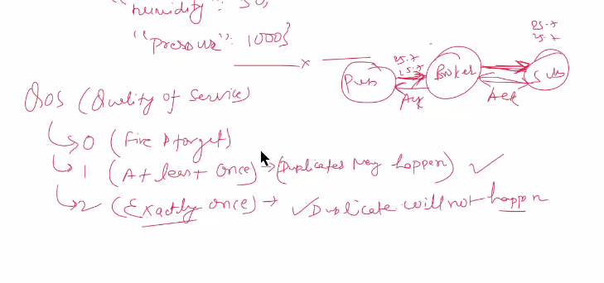

**Securing MQTT**

Follow the steps for securing

**Step 1:**

$ cd /etc/mosquitto

**Step 2:**

First take backup of your mosquitto.conf file

**Step 3:**

Then create new file mosquitto.conf and enter this few lines and save the file

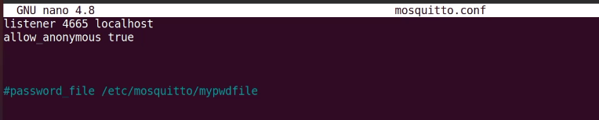

mosquitto.conf file for changing port number for securing our mqtt service

listener 1430 localhost

allow_anonymous true // this means that any user can connect to this port

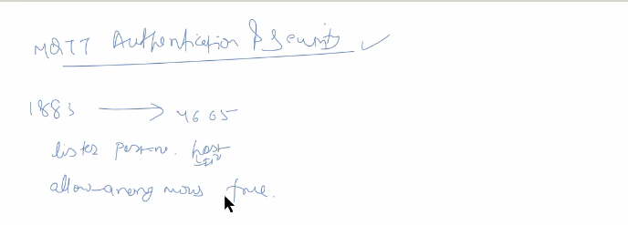

**Password**

1. Create a empty file using touch and give it a name of your choice
   1. sudo touch mypwdfile
2. Then give all the permissions of rwx
   1. sudo chmod 777 mypwdfile
3. Then using mosquitto_passwd set username and password for your file
   1. mosquitto_passwd -c mypwdfile <user_name>
   2. mosquitto_passwd -c mypwdfile mahi
4. This will ask for a password and enter your new password for your particular port number

Then in your mosquitto.conf file add the path of your password file

And set allow_anonymous false so no any other user can access the file.

And then restart your mosquitto.service

**Step 4: Restart mosquitto**

Then restart the system and if it execute successfully port is changed successfully

Restart is necessary, any number of times you change the content of mosquitto.conf configuration file.

sudo systemctl restart mosquitto.service

**Step 5:**

Run the publisher and subscriber with -p 1430 / -p <port no>

It’s necessary to mention port number as by default port number is 1883

**Publisher:**

mosquitto_pub -t iot/lab1 -m “hello” -p 1430

**Subscriber:**

mosquitto_sub -t iot/lab1 -p 1430

Here,

-u : user name

-P : password

As mentioned when ran this statement

* 1. mosquitto_passwd -c mypwdfile mahi

**Mongo**

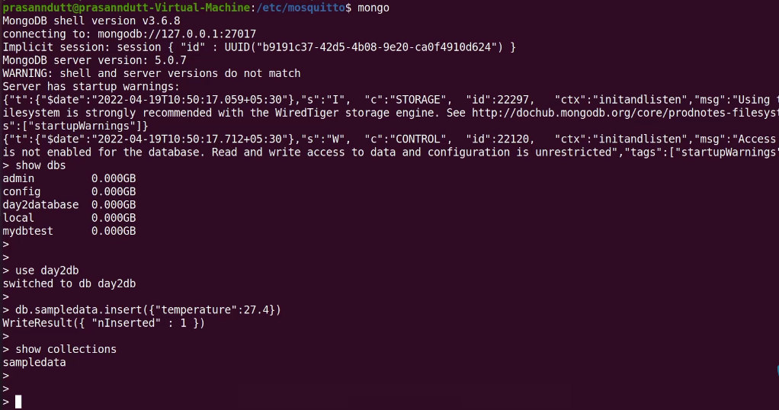

**Mongodb compass**

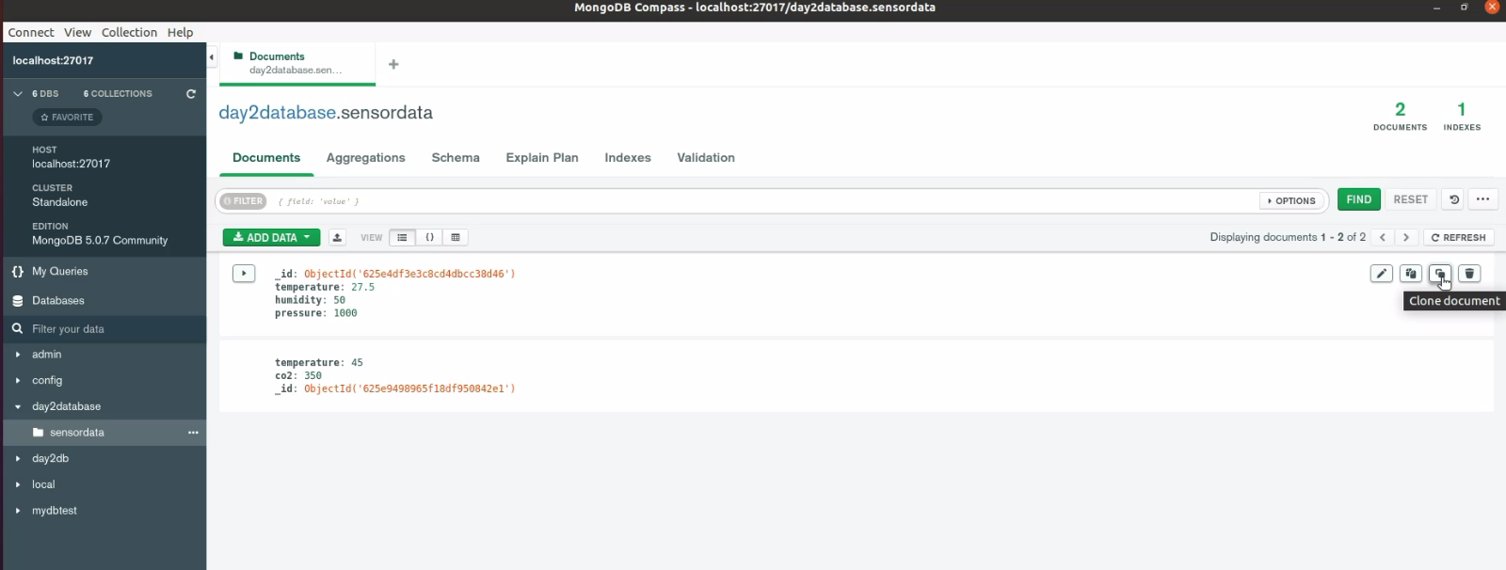

**Internet Protocol Stack**

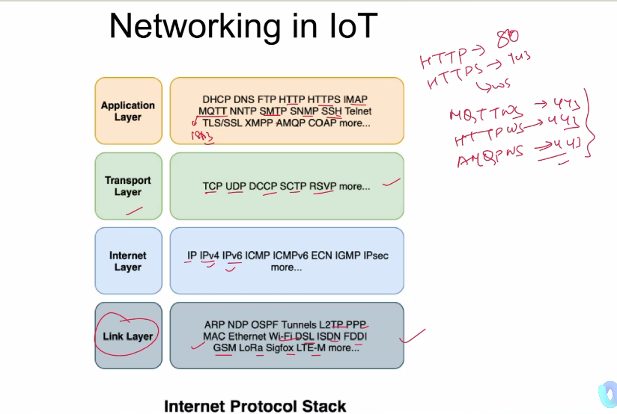

**Port numbers**

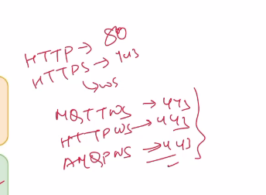

Http ⇒ 80

Https ⇒ 443

MQTTWS, HTTPWS, AMQPWS ⇒ 443

**Azure Portal**

Iot instance name format:

Region-service name-project name-sequence number

sindia-

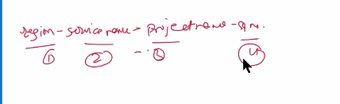

Device training

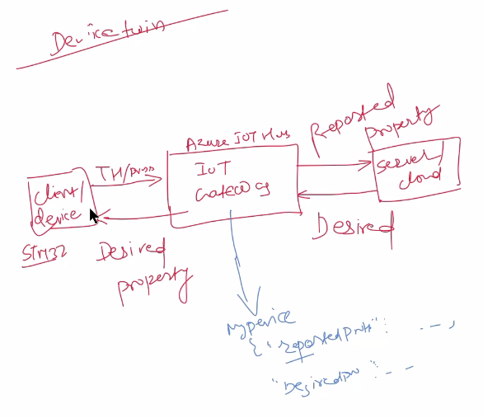

Client device

(stm32)

|

Azure IOT hub

IOT Gateway

|

Server

Cloud

2 properties

Reported property

Desired property: remotely firmware upgrade

Mostly it is only this two

D2C: device to cloud

C2D: cloud to device

**Azure iot hub sdk python**

<https://github.com/Azure/azure-iot-sdk-python>

**Azure device to client code**

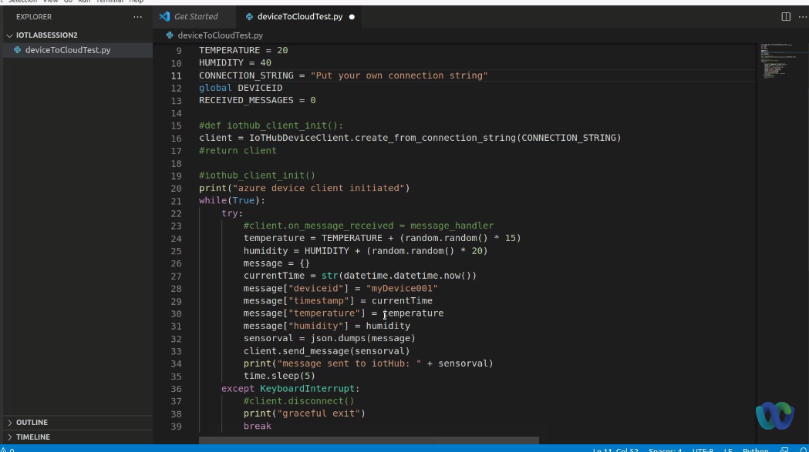

**IOT challenge**

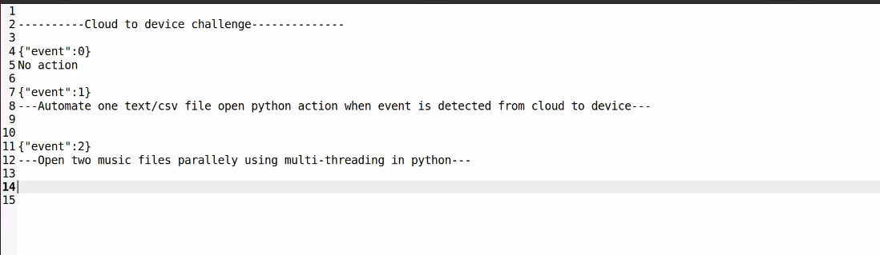

**Container storage services**

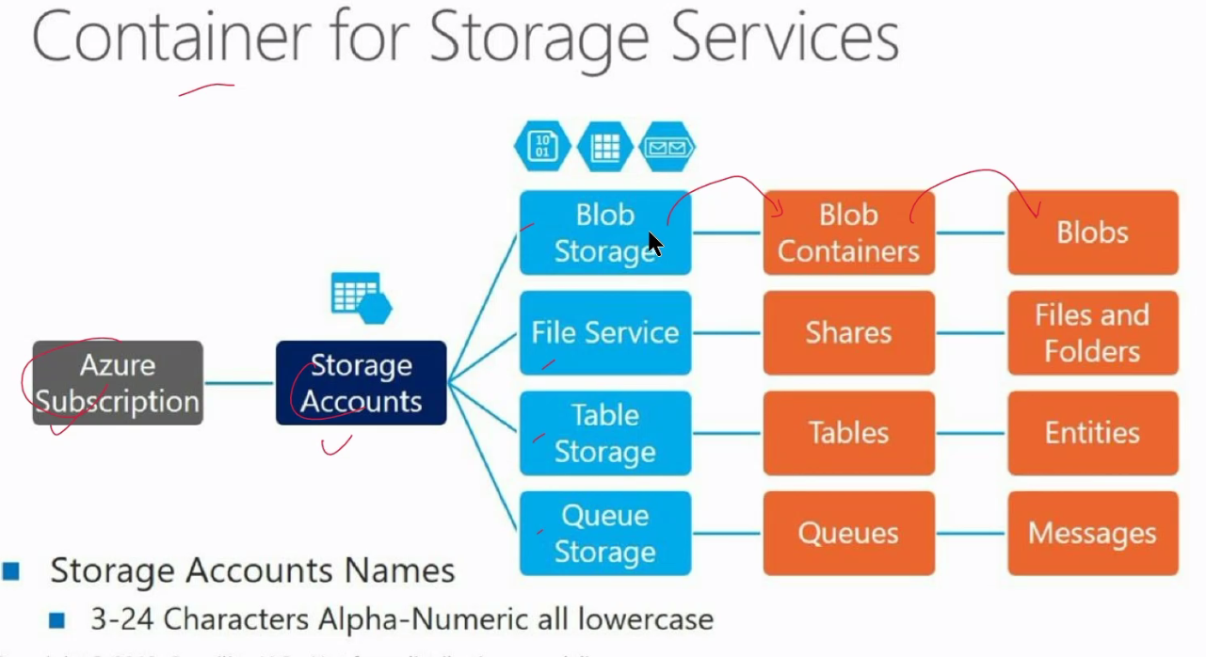

**Blob containers**

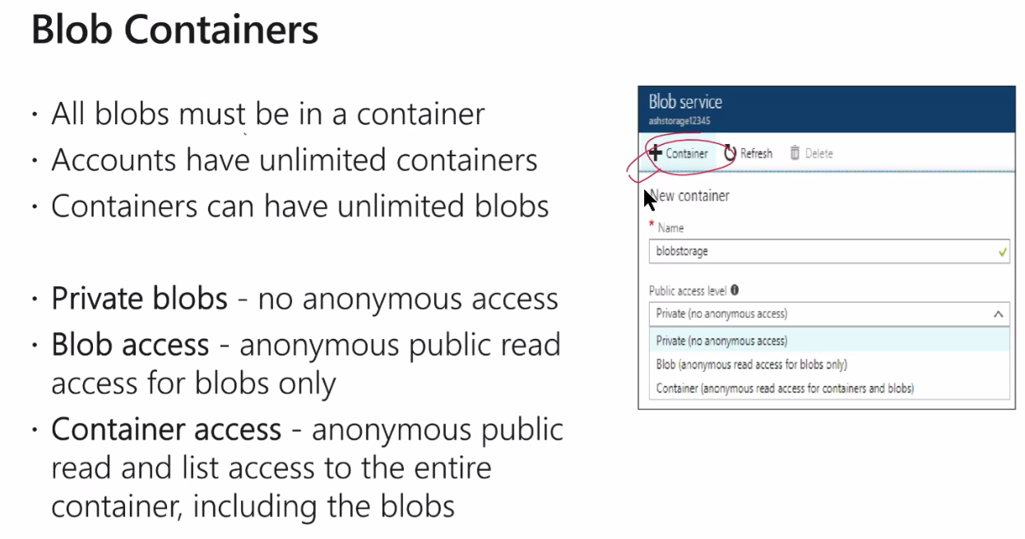

**Redundant storage**

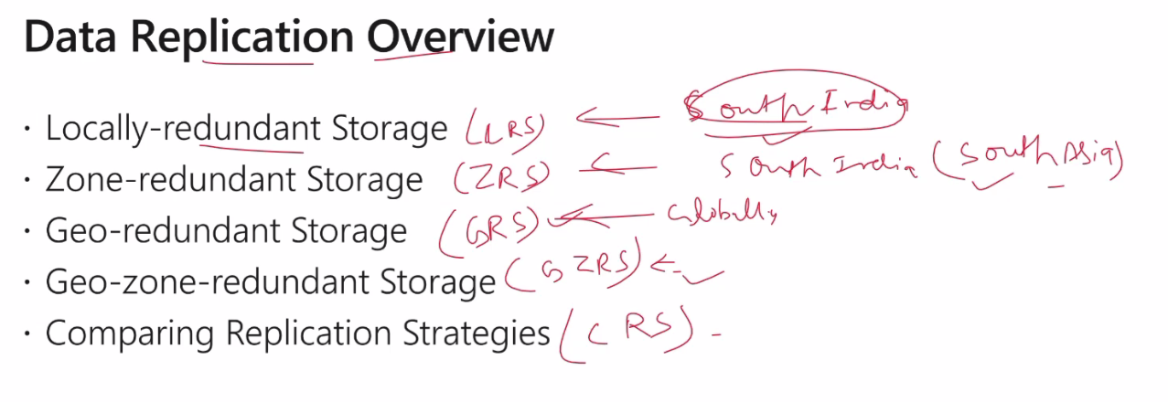

**Storage Tiers**

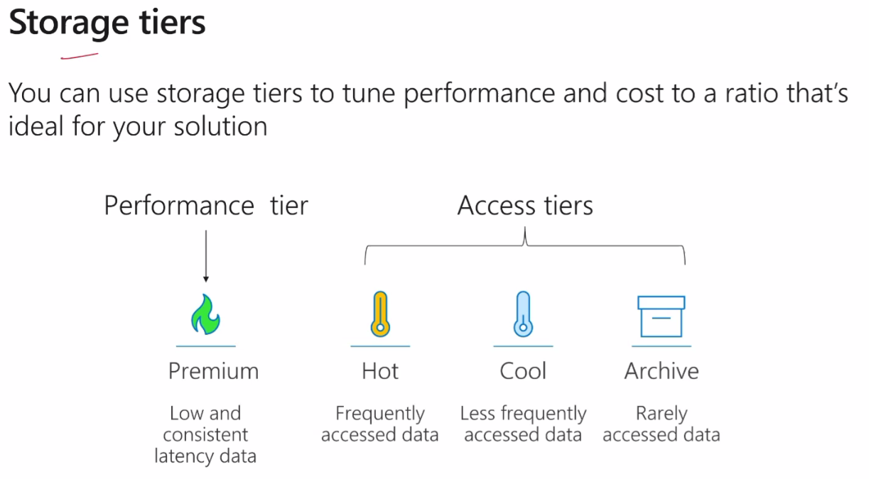

**Container**

1. Search storage containers
2. Create
3. For storage account name: all small letters , no capital , no special characters
4. (Asia pacific) south india
5. Performance : standard
6. Redundancy: LRS
7. Advance:
   1. Rest API
   2. Enable blob public access
   3. Enable Storage key access
   4. Minimum TLS : v1.
   5. Allow cross tenant
   6. Access tier: **hot** or cool
   7. Connectivity: Public endpoint
8. Data protection
   1. Enable Soft delete
   2. Keep as it is
9. Encryption: same
10. Tags
    1. Owner: rsjc26
11. Review+create

**Built-in-Endpoint**

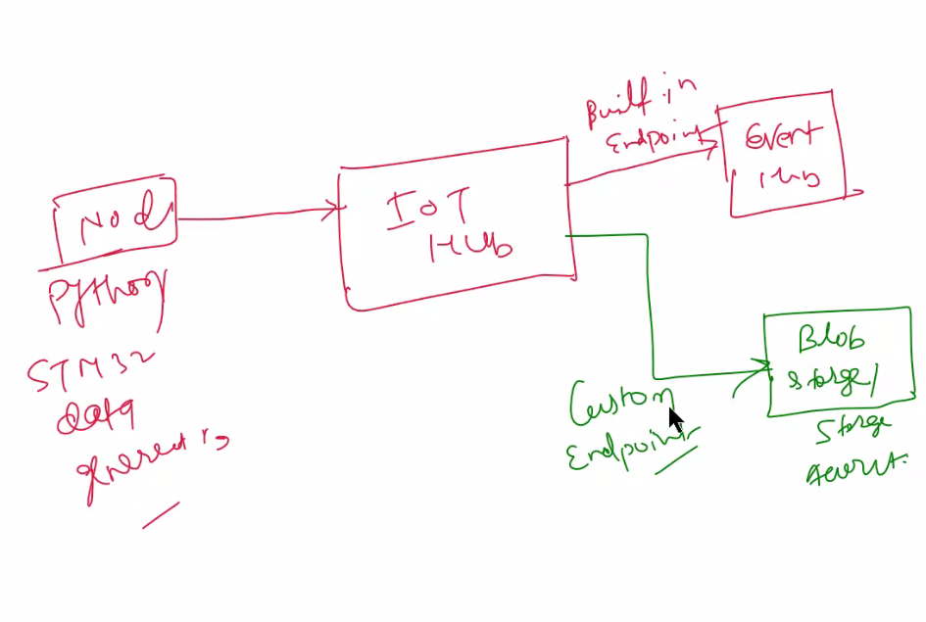

1. In blob ⇒ go to messaging routing
2. Create new storage endpoint ⇒ random endpoint ⇒ create ⇒ storage
3. Endpoint name: any [ iothubtraining-011]
4. Select container with the name you created
5. Remove all the slashes in year-month-data

Create route now

1. In blob ⇒ go to messaging routing
2. Route ⇒ create

